**FROM THE VILLAGE PRESIDENT**

**________________________________________________________________________________________________**_

**MARK YOUR CALENDARS!!**

**Sesquicentennial**

**July 16 – 20, 2025**

**Larry Franks**

I hope everyone had a safe and enjoyable summer. The village got caught up on some road work projects this year with the help of our new engineering firm. They’ve been great to work with and we look forward to them helping us with many other projects going forward. We apologize for some of the heavier rock that was laid down and will look to do better next year. We continue to work on drainage projects to keep the water from standing in ditches and residents’ property.

The board and I are very much looking forward to the 150th Celebration of the founding of Philo next summer. The committee is working hard to bring it all together. I hope you all will find some time to volunteer to make this a great event. The committee will soon start selling stock certificates and merchandise. They have also planned a glow bingo fundraiser. Look at the insert for all that they have planned.

I hope to see you all at the Christmas parade on Sunday, December 1. The parade starts at 5:00pm. The route will be the same as last year and will end at the Christmas tree for the lighting by Santa!

*Have a safe and healthy holiday season and a great new year in 2025!*



**Veteran’s Monument**

The Veteran’s Monument committee plans to add names next spring. If you or a loved one would like to be added, please contact Dick Miller or the village office for more information.

**IN OTHER VILLAGE HAPPENINGS**

# **VILLAGE OF PHILO NEWS**

## **Winter 2024 – 2025**

## **December - February**

Summary of notes from the meeting minutes:

**September** – Request for Frick to come do leveling and put in a culvert along Jefferson Street. A letter was sent to Champaign Public Health declaring the septic at the

R. E. Franks meeting Center is in good working order. Request for a Trees, Parks and Beautification Committee meeting. An update was given on the 150th Celebration committee meetings. Discussion of where to use the Kids’ Festival Committee funds. A proposal from Access Locksmiths for deadbolt repair at Hazen Park bathrooms and new locks at Hale Park was accepted. Request by Trustee Pioletti to start doing the Pledge of Allegiance prior to all meetings was accepted.

**October –** The drainage issue on Rt 130 is being addressed by engineering, village maintenance and IDOT. Discussion of the heavy dust from the road work was conducted. Treasurer reported that all accounts are in order. An update was given on the 150th Celebration committee meetings. Campus Ink Apparel will have an on-line shop in November. There will not be a carnival, but will be inflatables. The bands are being finalized. The repairs at Hazen Park are complete and the locks and security cameras are installed and working at Hale Park. Champaign County Animal Control contract was renewed.

**November** – Minutes will be approved at the board meeting to be held Wednesday, December 11, 2024 in the Eileen Painter Room of the R. E. Franks Meeting Center. The meeting will begin at **6:30pm**.

Meeting minutes are posted on the Village web site www.villageofphilo.com under the *About Philo-Village Board* tab after they are approved at the following monthly meeting. Meetings are held the 2nd Wednesday of each month at 7:00pm (with the exception of the December meeting held at 6:30pm) in the R. E. Franks Meeting Center located at 127 W. Washington Street. The public is invited to attend.

**Sledding!**

The snow will be flying soon. Sledding on the hill at the water tower is at your own risk. *Motorized vehicles of any kind are not allowed on the hill*.

**Snow Removal**

When there are two or more inches of snow on village streets, residents living on Washington Street in the downtown area are asked to park in the alleys between the hours of 12:00am and 6:00am so that the streets of Washington and Harrison can be plowed. Village maintenance also requests that anyone living in a cul-de-sac park in driveways or further off the road. Parking in the circle makes it too tight for the plow trucks to do a decent job.

***Exercise helps keep the winter blues away!!***

 **Exercise with Caution.** It’s great that so many people in the community enjoy getting out and walking, running, biking or taking care of their pets. The winter months bring challenges of getting these activities in safely. When outside, wear reflective gear and bright colored clothing. If it is dark, along with the reflective gear, wear or carry a light. Rules of the Road dictate that walkers and runners face oncoming traffic. When biking, follow the rules of moving with traffic. If you are on a hill, be sure to move to the side of the road and possibly stop until the vehicle has passed. Always assume the driver does not see you. Unfortunately, in this day of distracted driving they probably do not. Drivers, PUT DOWN THE PHONES! The R. E. Franks Center is open Monday – Friday from 7:00am – 9:00am when Hugs & Bugs is in session. No pets allowed.

**Pickleball at R. E. Franks Center**

You can play pickleball at the R. E. Franks Center on Sundays between noon – 3:00pm. This is a free event. Sign up at <https://villageofphilo.com/pickleball> or stop in and see if a court is open and someone is looking for a partner or competitor.

**Golf Cart & ATV Use**

**\*\*Any person who operates a golf cart must have a valid driver’s license and insurance coverage.

**Golf carts can be driven on streets after dark, only with proper qualifying equipment (headlights; taillights; signals; slow moving emblem).

**Open alcohol and/or drinking and driving are illegal.

***ATV’s and other off-road vehicles are NOT allowed on Village streets or properties, this includes the hill and drainage pond area.***

You can read the ordinance and print off an application on our village website under the ABOUT PHILO/Ordinances tab or contact the office Monday through Friday from 8:00 - 11:00am. Email inquiries to admin@villageofphilo.com or call 684-2562.

**Burning Regulations**

**The village burn area is off-limits to the public. Please do not dispose of yard waste or any other materials at the burn pile.**

Residents may burn leaves, sticks and other dry plant debris grown or generated on their property in a safe manner during daylight hours. Please be considerate of smoke direction and neighbors. Some residents have health issues that are adversely affected by smoke.

Materials prohibited from burning: tires and garbage, including bones, meat, animal skin, feathers, entrails, organs, non-edible animal parts, grease, food and food by-products, coffee grounds and other materials per Ordinance 2008-545.

**EASTERN ILLINOIS FOOD BANK** – Will be in Philo on the first Tuesday of each month. They will be located near the R. E. Franks Meeting Center at 127 W. Washington St. from Noon – 12:45.





**150th Celebration**

**SESQUICENTENNIAL 1875 – 2025**

**** SAVE THE DATE ****

## **JULY 16 – JULY 20, 2025**

**Village of Philo is Celebrating 150 Years!!**

WE NEED YOU! The dates have been set. Now, it’s time to start planning for the 2025 Sesquicentennial Celebration. If you have any questions or want to help, please contact any committee member or email [**philo150committee@gmail.com**](mailto:philo150committee@gmail.com).

**The next meeting is January 6, 2025 at 5:30pm in the**

**R. E. Franks Meeting Center Eileen Painter Board Room**. The public is invited and encouraged to attend. Whether you and your family have lived here your whole life or if you just moved to town, please reach out to someone to help with this historic event for the Village of Philo!

**150th Celebration Merchandise**

You will soon be able to order celebration merchandise through Campus Ink using the QR code or go to the online store. The store will **open on December 1 with a cut-off date of December 15**. Orders will be available for pick up at the R. E. Franks Center Board room on Saturday, December 21. The store will reopen on January 2, 2025.

<https://campusink.printavo.com/merch/46590-philo-sesquicentennial-celebration-online-store>

Sent from Front

**Glow Bingo Fundraiser**

The fundraising committee will be holding a Glow Bingo fundraiser on **Saturday, February 1** at the R. E. Franks Meeting Center. Watch the *Philo 2025 Sesquicentennial Celebration* Facebook page or go to the village web site https://villageofphilo.com/150th-anniversary-celebration/ for details.

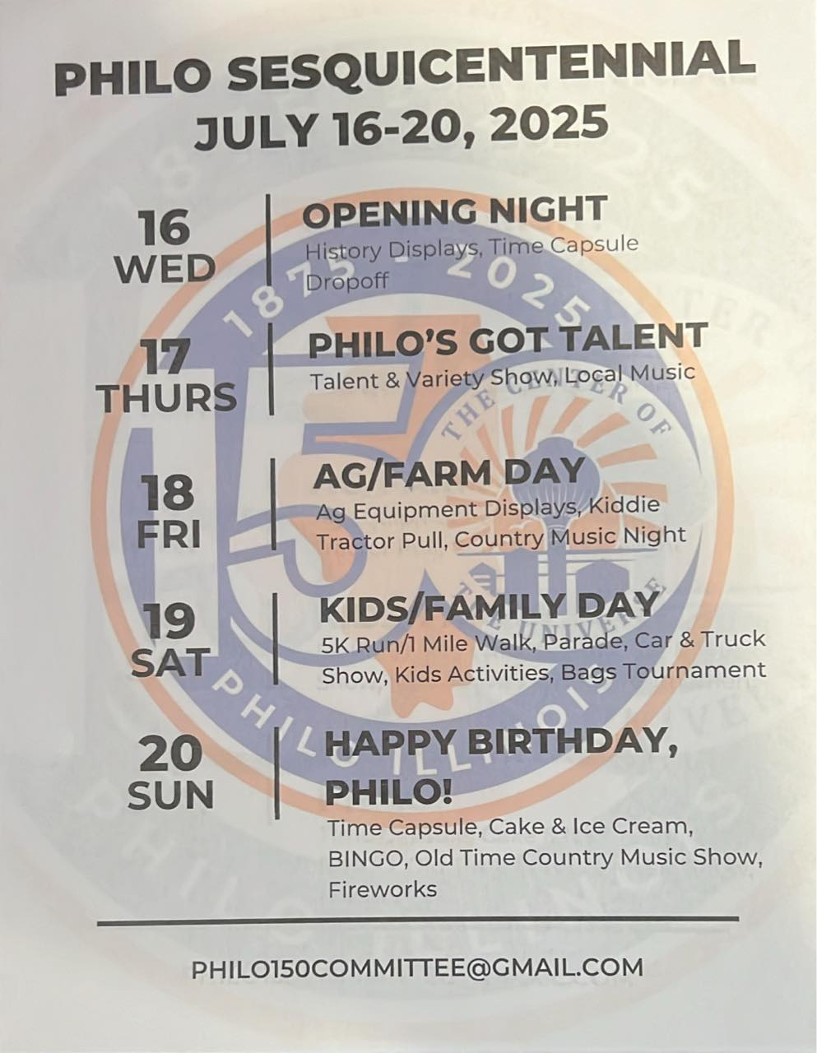

**Executive Committee**:

Chairs: Steve Sappenfield

Members: Molly Kelley; Craig Kirby & Dawn Graham; Katie Franks; Dirk Rice; Chris Cain

**Subcommittee members**: Jana & Larry Franks; Carolyn Rice; Tom Kelley; Dick Miller; Rod Schweighart; Erin Renfrow; Samantha Herriott; Jeff Cain; Judy Kirby; Julie Pioletti; Lisa Quinn; Cindy Schweighart; Lori Donovan; Craig Terven; Chris Payne and Courtney Grussing.

**Liaisons to the Village Board**: David Happ; Janet Decker

**Committees**:

Merchandise; Entertainment; Decorating; Marketing/Promotions; Competitions (Talent Show); Fundraising/Finance; Parade; Food/Vendors; Community Engagement; Farm/Ag; History/Time Capsule; Games/Inflatables; Fireworks.

**Clergy Corner**

**Countryside United Methodist Church –** Located at: 1807 County Road 1000 North, Urbana (between Sidney & Philo) – (217) 688-2422; [cumc.office99@gmail.com](mailto:cumc.office99@gmail.com)

Events/Services

--Sunday Worship Services @ 9:00am; Childrens service is at 9:15am. Nursery care is available. Adult Sunday School is at 10:15am

-- **December 15 @ 5:00pm** “Christmas by the Fireplace”!Enjoy a cozy evening filled with delicious food and delightful entertainment. Celebrate the holiday season in a warm & inviting atmosphere.

--**5:00pm Christmas Eve Service**

**Philo Presbyterian Church—**105 E. Jefferson, Philo

Follow our Facebook page for up-to-date information: <https://www.facebook.com/philopres/>

--Worship Services – Sunday mornings @ 9:30am

For more information contact [philopresbyterianchurch@gmail.com](mailto:philopresbyterianchurch@gmail.com)

**St. Thomas Catholic Church** – 310 E. Madison Street

Sunday Mass Times:

- 7:30am @ St. Mary’s Pesotum

- 9:00am @ St. Thomas Philo

- 11:00am @ St. Thomas Philo

-- **Christmas Eve Mass Schedule**

Tuesday, December 24th

4:00 pm--St. Thomas Church, Philo

6:30 pm--St. Mary's Church, Rural Pesotum

10:00 pm--St. Thomas Church, Philo

--**Christmas Day Mass**

9:00am –St Thomas Church, Philo

-- visit the Facebook page <https://www.facebook.com/StThomasPhilo>; visit their web page at [www.church.stthomasphilo.org](http://www.church.stthomasphilo.org) or call (217) 684-5107.

**Zion Lutheran Church** – 101 W. Van Buren St., Philo IL

--Weekly Sunday service @ 9:30am; After January 1 time will move to 10:30am. Communion Sundays will be the 2nd & 4th Sundays in 2025.

--Sunday School Christmas Program **December 22** during regular worship @ 9:30am.

--Candlelight Christmas Eve service **December 24 @ 5:00pm**

Follow our Facebook page for up-to-date information: <https://www.facebook.com/ZionLutheranPhilo>

**The Giving Place** – Tolono serving local families. Clothing give away the first Saturday of the month. Food distribution on Wednesday’s 4:00 – 6:00pm. They also accept donations.

**St. Patrick Parish Food Pantry** located in Tolono at 304 E. Vine -- free food available on Monday’s 5:00 - 6:30pm and Friday’s 9:00 - 10:30am. No residency or income qualifications. They also accept donations.



**Library Programs & Information**

To stay up-to- date on happenings with the Philo Public Library District, follow our Facebook page (<https://www.facebook.com/PhiloPublicLibraryDistrict>) and website (<http://www.philolibrary.info/>) or call the Library at 684-2896.

Please join us at the library at 115 E. Washington St.

Our hours are:

--Monday-Friday: 9:00am - Noon, 3:00 -7:00pm

--Saturday: 9:00am – 1:00pm

**--CLOSED DECEMBER 24, 25, 31 & JANUARY 1**

**Library Board Meetings**

--Third Tuesday of each month at 7:00pm -- Public is invited.

**Thursday Coffee Hour**

Each Thursday starting at 10:00am there will be an opportunity to enjoy a cup of coffee, catch up with old friends and neighbors and meet new ones at Philo Library's "Coffee Hour". Everyone is invited to this free event.

***Local School & Pre-School Options:***

***Hugs & Bugs Daycare & Preschool*** is located at 127 W. Washington St. in the R.E. Franks Meeting Center building. They are accepting applications. Call (217) 689-8651 for more information.

***St. Thomas School*** is accepting registrations for preschool (3- to 5-year-olds) and kindergarten through 8th grade. Call the school office at (217) 684-2309 to schedule a tour. All faiths welcome.

**Happening this Winter!**

**Annual Tree Trimming**

Sunday, December 8 the Philo Public Library will be hosting their annual Ornament Workshop. From 3:00 – 4:00pm children are invited to visit “stations” set up throughout the library. Each station has a kid friendly craft to make and take home. The kids will be proud of their treasures and parents will treasure the artwork. From 4:00 – 5:00pm join in singing Christmas carols and proceed outside with ornaments provided by the “elves” at the back door. After the ornaments have been hung and the tree is lit, return inside for refreshments.

**Read with Dogs**

Friday, December 27 from 11:00am – Noon, service dogs will be visiting Philo Public Library. Paw Print Ministries from Decatur is arranging for certified service dogs to spend an hour listening to elementary aged children practice their reading skills. Check with Miss Sue anytime AFTER December 8 for more information and to sign up to read with the dogs.



**Christmas Gift Ideas**

**Brick Orders Still Being Accepted**

Did you or your kids/grandkids play t-ball or coach pitch at Hazen Park, the “little diamond”? Why not commemorate those times with their name on a paver? Brick orders are still being accepted for Hazen Park. You can pick up order forms in the R. E. Franks Center on the shelves outside of the administrative offices. The cost is $100 for an individual 4” x 8” paver or $250 for a business 8” x 8” paver. They will be ordered in time for install before the 150th Celebration in July.

**Parade Committee Ornaments**

The parade committee will be selling ornaments throughout December. You can find them at the Philo Exchange Bank. Great stocking stuffers!

**Santa Breakfast**

The annual Santa Breakfast hosted by the Philo Exchange Bank will be held on **Saturday, December 7 from 9:00am – 11:00am** at the R. E. Franks Center gym, 108 W. Madison St. in Philo. Come enjoy donuts, games, gifts & Santa. Bring a toy donation for Toys for Tots and receive 10 free game tickets. Additional tickets are .25 cents each.

**BRUSH PICK-UP**

Brush pick-up has concluded for the season.

**Christmas tree pick-up will be on Monday, January 13, 2025**

**DO NOT PILE PLOWED SNOW IN ROAD OR ALLEYWAYS. KEEP IT ON YOUR PROPERTY AND AWAY FROM STORM DRAINS.**

If you have questions, please contact

Dave Traxler at 684-2674.

**Pancake & Sausage Breakfast**

The Annual St. Thomas Pancake & Sausage Breakfast will be held Sunday, January 19, 2025 from 7:00am – 1:00pm in the John Schumacher Gymnasium at St. Thomas School.

**Trivia Night**

St. Thomas Trivia Night will take place on Saturday, March 1, 2025. Doors open at 5:00pm & Trivia starts at 6:00pm. Reservation will open in January. Teams of 8 per table.



**Administrative Office and Maintenance**

**Holiday & Vacation Closures**

**Administrative Office:**

January 8 – 31 (No office hours; contact via email or phone – see below)

**Admin & Maintenance:**

Dec.24, 25 & 31

January 1; January 20

February 17

**Village Board and Officials**

|  |  |  |
| --- | --- | --- |
| **Village President**  Larry R. Franks . (217) 377-1454  LRFranks11@yahoo.com  **Village Clerk**  Judy Kirby ...............jkirby@villageofphilo.org or jjkirb@icloud.com; (217) 621-5404    **Village Treasurer**  Kevin Chalmers………….(217) 441-2927    **Trustees**  (all area code 217)  Tom Kelley………369-6690.. tom.kelley@syngenta.com  David Happ............417-3128...Happs65@yahoo.com  Pat Pioletti............. 493-9069.. pw64@comcast.net  Steve Messman … 493-8762.messmanfarms@comcast.net  Tim Grubb…….…202-2106..tgrubbppi@comcast.net  Terri Shipley…..…202-6019…tshipley1968@gmail.com    Village of Philo  127 W. Washington St.  P.O. Box 72  Philo, IL 61864-0072 | **Village Deputy Clerk & R. E. Franks Meeting Center Rental Coordinator**  Janet Decker.. 684-2562.. admin@villageofphilo.com  127 W. Washington St., Monday - Friday 8am – 11am    **Village Maintenance Supervisor**  David Traxler ... 684-2674…dtraxler@villageofphilo.org  105 E. Washington St., Monday-Friday 7am - 4pm  **Philo Planning Commission**  Chris Payne, Co - Chair ............................... 684-2226  Karl Helmink, Co - Chair.......karl.helmink@comcast.net  **ESDA Co-Coordinators**  Chris Lueth …………………………377-9627  Richard Brand ...................................... 778-8259   |  | | --- | | PRSRT STD  ECRWSS  U.S. POSTAGE  PAID  EDDM Retail | |

**\*\*\*\*\*\*\*\*\*\*\*\*\*\*\*\*\*ECRWSS\*\*\*\***

**Local**

**Postal Customer**