BACK•A•BRICK

PHILO KIDS’ FESTIVAL’S
BUY A BRICK PROGRAM
FOR PLAYGROUND RENOVATION

COMPLETE ORDER FORM BELOW AND RETURN WITH PAYMENT TO THE FOLLOWING ADDRESS:
PO BOX 253
PHILO, IL 61864
Make Checks Payable to: PHILO KIDS’ FESTIVAL
Please direct questions to philokidsfestival@gmail.com

*ORDER FORM/PAYMENT CAN ALSO BE DROPPED OFF AT THE VILLAGE OFFICE.

INDIVIDUAL: ☐ 4” X 8” Brick Paver (max 3 lines of 20 characters, including spaces) $100
Choose your look:
☐ All Capital Letters
☐ Capital & Lower-Case Letters

BUSINESS: ☐ 8” X 8” Brick Paver (max 6 lines of 20 characters, including spaces) $250
Choose your look:
☐ All Capital Letters
☐ Capital & Lower-Case Letters

CONTACT INFO (IN CASE OF ANY QUESTIONS)
Name: _________________________________________________________
Phone: _________________________________________________________
Email: _________________________________________________________

As a fundraising committee, we are not only happy to work toward an annual festival for the community, but we also work with the Village of Philo to contribute funds to make our playgrounds more enjoyable.
Through the end of this year, we will be collecting orders for bricks to provide a patio or pathway (depending on quantity of bricks to be installed) at Hazen Park. Not only will your name be engraved into Philo history, but each purchase of a commemorative brick will donate several dollars toward giving our kids this amazing playground to use for years to come.

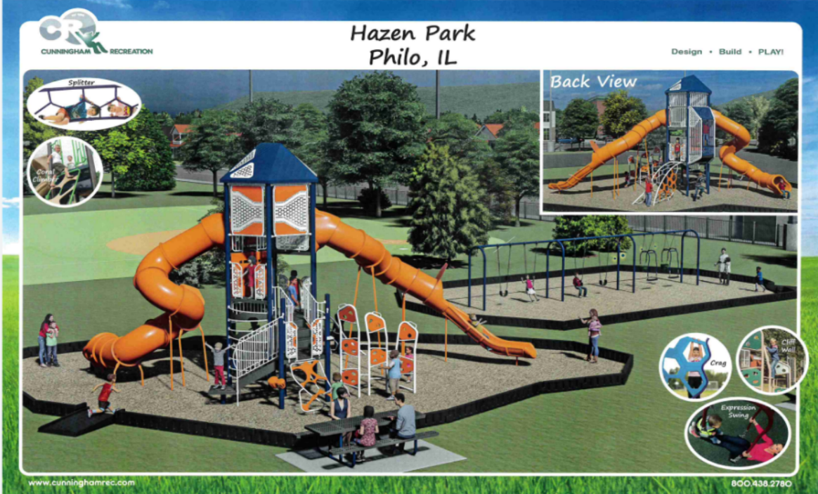

As always, we appreciate your constant support in making Philo’s Festival a success. We also thank you for your help in making this fundraiser a success.

