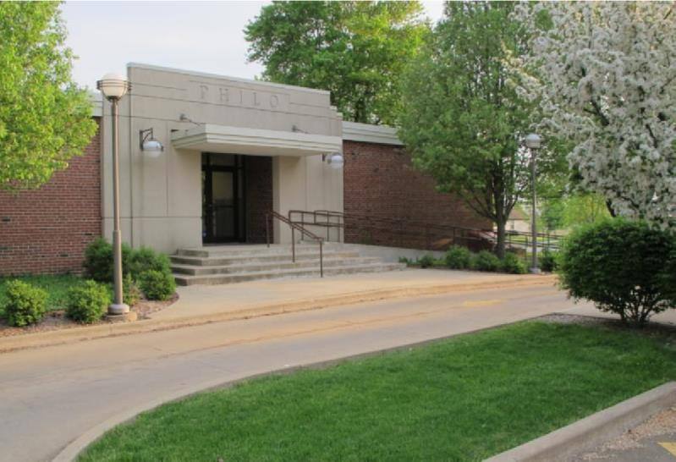

PRSRT STD
ECRWSS
U.S. POSTAGE
PAID
EDDM Retail

Village of Philo
a.k.a. “Center of the Universe”

Fall 2022
September - November

FROM THE VILLAGE MAYOR
By: Larry Franks
I am happy to report that the Hazen Park playground project is nearing completion. There are a few details that still need some work, but we (the Board of Trustees and Playground Committee) are really pleased with the outcome. We are upset that someone has already vandalized the new equipment and there have been attempts to break into the concession stands at both parks. We will be installing security cameras in the near future to help discourage this kind of behavior in our community. Philo is not the only community suffering from these types of issues and I hope if you have any information, you will come forward and help keep our community safe.
Another safety issue is the number of complaints I receive on a daily basis regarding speeding throughout the community. It is a problem! Please slow down! We are working on upgrading our existing sidewalks and will try to add new as funds allow. However, there are a lot of people walking their pets and kids riding bikes. I would hate for it to take a tragedy to get people’s attention to slow down. Also, do not let your underaged kids be driving the golf carts, even if you are with them. The ordinance states that drivers must have a valid driver’s license.
The parade committee has informed me they are looking for dates to continue with this great new tradition of a Christmas parade of lights. I look forward to hearing more details.
GO ROCKETS!
This Photo by Unknown Author is licensed under CC BY

IN OTHER VILLAGE BOARD HAPPENINGS

Meeting Minutes Summary:
June – Steve Khachaturian thanked the board for the Welcome for his Stevie J Broadcasting. MFT and summer project schedules were reviewed. Final plans for Phase II of the Storm Sewer Extension project were presented. Hazen Park progress presented. Fillmore sidewalk project tree removal discussed. Bids presented for updated heating in the village maintenance shed. Request from board member for weed control on the hill. Discussions on media presentation equipment for board meetings; security options at ball park concession stands and general village safety. Request from K of C to place a Christmas tree at intersection of Washington & Harrison Streets.
July – Extensive discussion concerning speeding in the village and how to alleviate the problem. Suggestions: portable radar signs; additional sheriff patrols and lowering the speed limit. All members were in agreement that more stop signs were not the answer. Village engineer Buzicky presented reports for Storm Sewer Extension Phase II; IDOT schedules and prices for MFT 2022 projects. The decision was made to complete the work on Washington Street and do as much oil & chip as we can. The 2022-2023 Appropriations Ordinance was presented by village attorney Marc Miller and passed unanimously. Bids for video surveillance were presented by Trustee Happ. The Board voted unanimously to approve a 3% wage increase for all village employees.

Meeting minutes are posted after they are approved at the following monthly meeting. The agenda for each meeting is posted on the Village web site www.villageofphilo.com 48 hours prior to the meeting under the About Philo-Village Board tab. The public is invited to attend meetings.

Burning Regulations
The Village provides twice monthly brush pickup. However, residents may burn leaves, sticks and other dry plant debris grown or generated in Philo in a safe manner during daylight hours. Please be considerate of smoke direction and neighbors. Some residents have health issues that are adversely affected by smoke.
The village burn area is off-limits to the public. Please do not dispose of yard waste or any materials at the burn pile.
Materials prohibited from burning: tires and garbage, including bones, meat, animal skin, feathers, entrails, organs, non-edible animal parts, grease, food and food by-products, coffee grounds and other materials per Ordinance 2008-545.

Transient/Solicitation/Peddlers Permits
The Village has an ordinance for door-to-door sales. Persons wishing to go door-to-door for solicitation are required to obtain a permit from the village office. This does not apply to schools, Scouts and other local fundraising groups. Solicitation hours are 8:00am to 8:00pm and the permit is $10 per person per day. Solicitors are issued a permit that they must carry with them while in the village and show upon request.

If you have questions or need further information about these or any other ordinances, please contact the office at 684-2562.

Golf Cart Registration & ATV Use
Renewal Letters went out to current permit holders in April. The biennial permit fee is $50. A new sticker will be issued at renewal. The renewal date is May 1. Please contact the office to renew or register your cart.
ATV’s, Snowmobiles and other off-road vehicles are NOT allowed on Village streets or properties, this includes the hill and drainage pond area.

Exercise With Caution!
It’s great that so many people in the community enjoy getting out and walking, running, biking or taking care of their pets. To help enjoy the outdoors safely, please wear reflective gear and bright colored clothing. If it is dark, along with the reflective gear, wear or carry a light. Illinois Rules of the Road dictate that walkers and runners face oncoming traffic. When biking, follow the rules of going with traffic. Be aware of your surroundings. If you are on a hill, be sure to move to the side of the road and possibly stop until the vehicle has passed. Always assume the driver does not see you. Unfortunately, in this day of distracted driving they probably do not. Drivers, PUT DOWN THE PHONES! The R. E. Franks Center is open Monday – Friday from 7:00am – 9:00am (no pets allowed) for walking. Please use the gym entrance.
LAST BRUSH PICK-UP
December 1
(Christmas tree pick up will be mid-January)

- Brush pick-up is done on the 1st and 15th of each month (weather permitting) through December 1. If those dates fall on a weekend or holiday, the pick-up will be the following business day.
DO NOT PILE BRUSH IN ROAD OR ALLEYWAYS. KEEP IT ON YOUR PROPERTY AND AWAY FROM STORM DRAINS.
Do not take brush to the Village brush disposal area.
If you have questions, please contact Dave Traxler at 684-2674.

Marvin Lee -
Summer Concert Series
Marvin Lee’s country music concert series continues in Hale Park the first two Tuesdays in September. This is a free event open to the public. Bring your lawn chairs and enjoy the late summer evening in Philo. The Philo Fire Department is planning to be back with pork chops on hand for a fee.

**The Philo Country Music Show with Ed Clem is TENTATIVELY set for Sunday, November 6 @ 3:00pm. Watch for posting in the post office and Tavern.**
This Photo by Unknown Author is licensed under CC BY-NC-ND
Village-Wide Garage Sales
The fall Village Wide Garage Sales will be held on Friday, September 23 and Saturday, September 24. To be listed on the map call or email the office at (217) 684-2562 or admin@villageofphilo.com. There is a $5 fee.

Community Clean-Up & Recycling Day
The semi-annual Community Clean-up and Recycling Day is scheduled for Saturday, October 1. The dumpsters will be located at the corner of Washington and Adams Streets from 7:00am - noon. We hope everyone will take the time to use this service to help keep our community beautiful. These services are provided for Village of Philo and Philo Township residents only.
Items that cannot be put in the dumpsters are
Tires Batteries
Paint Motor Oil
Propane Tanks Acid or Alkaline Products
Any other Hazardous Materials
Grass clippings, brush or other yard debris

You can find a complete list of acceptable/unacceptable materials on our website www.villageofphilo.com under announcements and also posted at the front of the village offices and the post office.

Trick or Treat Hours
Trick or Treating hours are set by the Board of Trustees. The hours will be
6:00 - 8:00pm; Monday, October 31.

DAYLIGHT SAVING – FALL BACK
Sunday, November 6

Election Night Stag (and Doe)
The Philo Knights of Columbus are hosting an Election Night Stag (and Doe) on Tuesday, November 8. Doors open at 5:00 pm with a $10 donation at the door. Join us for chicken or fish and a cold beverage. Blackjack, poker, craps and other games of chance will be available. The event is open to anyone 21 years of age and older. The hall is located at 108 S. Harrison – east of the Tavern.

Remember Our Veterans
Friday, November 11 --

Veterans Day will be observed on

Friday, November 11 at state and

local government offices, banks and other businesses to honor our veterans.

Mark Your Calendars!

Philo Exchange Bank will host the Annual Santa Breakfast
Saturday, December 3; 9:00am – 11:00am in the gym at the R. E. Franks Center. Please join us for donuts, games, gifts, and Santa!

The Christmas Parade of Lights is in the works. Watch for details!

Staying Safe -- Tips from the Champaign County Sheriff’s Office
- Secure your residence when not home (lock, doors, windows, garages/sheds)
- Do not leave your vehicle unlocked and/or keys in the vehicles
- Keep a current inventory of items in your home/garage/sheds/storage units
- Limit the number of people who have a key to the residence or garage door code
- Make sure your house is well-lit and has functional indoor & outdoor lighting
- Consider purchasing home security devices and/or motion detector lights
- Pets are a good deterrent as well
- Keep foliage around the house trimmed to avoid blind/hiding spots
- If out of town, have someone check the residence. You can also request a “vacation watch” through the Champaign County Sheriff’s Office.
- Do not publicize on social media that you will be or are out of town
- Report suspicious vehicle activity in the area

Did you know…
The speed limit on village streets is 30 mph unless otherwise posted. Use common sense in residential areas and share the road.
The Hill
Motorized vehicles of any kind are not allowed on the hill any time of the year.

Clergy Corner
The Giving Place – Tolono
The Giving Place is a Christian ministry serving families in need in the Unit 7 school district. The hours of operation for donations and distribution of non-perishable food and clothing are Wednesdays 4:00 – 6:00pm and the 1st Saturday of each month from 9:00am – Noon (one person per family; no children). Non-perishable food and clean, slightly used clothing sizes from newborn to adult are the only items accepted (we have limited space and do not have refrigeration or washing machines). *Please do not leave donations outside of the building when the building is closed. The Giving Place wishes to thank all that donate to this ministry.

Zion Lutheran Church –
Located at: 101 W. Van Buren St., Philo IL 61864
New Worship Time: Sunday services at 9:30am. Sunday School meets weekly for children ages 3 and up during service beginning on September 11. Follow our Facebook page for the most up to date information: https://www.facebook.com/ZionLutheranPhilo

St. Thomas Catholic Church and School –
Located at 310 E Madison St, PO Box 266, Philo, IL 61864
Weekly and Holy Day Mass schedules are on our web site at Saint Thomas Catholic Church | Philo, Illinois (stthomasphilo.org) You can also participate in our live stream Masses on our Facebook page at St. Thomas Catholic Church – Philo.

Philo Presbyterian Church –
Located at 105 E. Jefferson St., Philo IL 61864
Worship Service every Sunday at 9:30 a.m.
Our congregation is currently searching for a new pastor. For the next several months, different clergy from the area will be leading our worship services. Philo Presbyterian Church, along-side the Tolono Presbyterian Church, sponsors the Philo-Tolono Youth Group (PTYG) which is a non-denominational Christian-based group open to any student attending Unity High School. The
group has been part of the community since 2005 and strives to help youth grow in faith, learn how to apply faith in daily life, develop lasting friendships and serve others in the community and beyond. For the 2021-2022 school year, PTYG will be meeting every other Sunday at various locations from 4:00 - 6:00 (unless otherwise noted). Please contact the Church Secretary for more information at churchsecretary@tolonopres.org .

Library Programs & Information
To stay up-to- date on happenings with the Philo Public Library District, follow our Facebook page (https://www.facebook.com/PhiloPublicLibraryDistrict) and website (http://www.philolibrary.info/) or call the Library at 684-2896.
Please join us at the library at 115 E. Washington St.
Our hours are:
--Monday-Friday: 9am-12N, 3pm-7pm
--Saturday: 9am-1pm

Library Board Meetings
Third Tuesday of each month at 7:00 pm Public invited.

Thursday Coffee Hour
Each Thursday starting at 10:00 a.m. there will be an opportunity to enjoy a cup of coffee, catch up with old friends and neighbors and meet new ones at Philo Library's "Coffee Hour". Everyone is invited to this free event.

Local School & Pre-School Options:
Hugs & Bugs Daycare & Preschool is located at 127 W. Washington St. in the R.E. Franks Meeting Center building. They are accepting applications. Call (217) 684-2300 for more information.

St. Thomas Catholic School is accepting registrations for preschool (3- to 5-year-olds) and kindergarten through 8th grade. Call the school office at 684-2309 to schedule a tour. All faiths welcome.

About Philo – Business Spotlight
Any aspiring writers or journalist out there? Each quarter we would like to give students the chance to spotlight a local business. Please reach out if you would be interested in sharing your business with the community. Business owners can also submit content. Contact admin@villageofphilo.com The next deadline for submission will be November 11, 2022.

Stevie Jay Broadcasting
By Elsie Wiesbrook – 7th Grader at St. Thomas School

​ Stevie Jay Khachaturian is a local radio personality who owns stations ESPN 93.5, US 105.9, Q96, and Christian FM 95.3. He started in radio in 1977, and joined WLRW in 1979 as DJ from midnight to 6 am! When he was 21, he got to do play by play for University of Illinois Football. He started his talk radio career in 1984 for WDWS, eventually becoming station manager and vice president of the News-Gazette in 1998. In 2010 he bought the stations he owns today.
​ Every day, Stevie has to stay up to date on topical things, but he says it is fun. His radio discussions have become more issue oriented in recent years. He hopes to entertain and get people to think so he asks a lot of questions. He says that you must have an opinion when working in talk radio. He says a good talk show emits reaction. Stevie says that radio is the only medium where you can truly create a relationship through voice. He tries to represent those who are afraid to speak up, for which he is often thanked. He tries to always maintain a positive attitude and tries to be a “Possibilitarian!”
​ He loves connecting with people and has interviewed tens of thousands of people including Charlton Heston, Doris Day, Muhammad Ali, Brooke Shields, Wayne Newton, George W. Bush and Barack Obama. But with all of his accomplishments, he is most proud of being husband to Janet and father to Nathaniel and triplets Christian, Benjamin and Grace.
​ In his spare time, he enjoys going boating and traveling. He owns a travel company (steviejaytravel.com) and hosts tour groups with his family. He says you really get to bond with people during travel. He has some interesting stories to share about this.
​ Stevie Jay Broadcasting moved from Urbana to Philo recently, as Philo is where he was raised. Stevie says he is doing things differently in the business of radio with a new program called Stever where listeners are offered money almost every day to shop at his “featured business of the day.” Sign up at GoStever.com!
​ You can listen to Stevie and his co-host Diane Ducey on their M-F radio show from 7-9am on ESPN 93.5 FM and also Facebook Live and Twitter. Their show is also podcast at StevieJay.com. Regular guests include his brother Jonny and former Chicago Bears coach Mike Ditka.
​ Connect with Stevie Jay to discuss your advertising needs at 217-840-9913 or sjk@sjbroadcasting.com. Check out his website at steviejay.com.

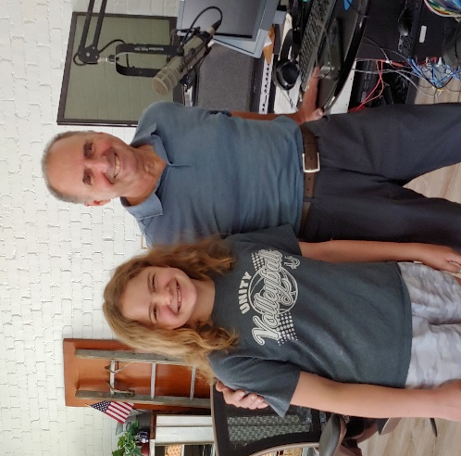
Photo Caption: Elsie and Stevie Jay at the new SJ Broadcasting studios in downtown Philo.

Philo Phlashbacks

February 1965
CD Survey Shows 875 Philo Residents
The Civil Defense Survey of Philo has finally been finished. Mrs. Alda Rice, chairman, reports several interesting facts from all the compiled statistics. There are now 875 people living in Philo comprising 256 families: 460 adults and 415 children. There are 99 children and 96 adults (51 families) on the north side; 134 children and 152 adults (94 families) living on the southwest side; and 182 children and 213 adults (111 families) living on the southeast side. Adams Street being the dividing line. There are 21 families having 5 or more children. There are 81 people in our community over 65 and 34 children under 2 years of age; 32 people are living alone. These 256 families have been contacted either by personal call, by telephone or by queries from the neighbors or relatives if persons were not found at home after repeated calls. We hope we have not missed a family and that all of this is accurate. All of this information, collected by members of the Philo Senior Women’s Club, has been turned over now to the Civil Defense Chairman of Philo, Bud Anthony.

Upcoming Village Holiday Schedule

Office & Maintenance Closed on the following days:

Monday, September 5 – Labor Day Observed

Tuesday, November 8 – Election Day

Friday, November 11 – Veterans Day

Thursday & Friday, November 24 & 25 -- Thanksgiving

Village Board and Officials
Village President  Larry R. Franks . (217) 377-1454  LRFranks11@yahoo.com  Village Clerk  Judy Kirby ............... (217) 684-2118  Village Treasurer  Kevin Chalmers………….(217) 441-2927  Trustees  Tom Kelley………369-6690.. tom.kelley@syngenta.com  David Happ............417-3128...Happs65@yahoo.com  Pat Pioletti............. 493-9069.. pw64@comcast.net  Paul Brady …….... 684-2540.. paul-brady@comcast.net  Rachael Garrett…. 714-8484.. rachaelgarrett@comcast.net  Steve Messman … 493-8762.messmanfarms@comcast.net  Village of Philo  127 W. Washington St.  P.O. Box 72  Philo, IL 61864-0072 | Village Deputy Clerk & R. E. Franks Meeting Center Rentals  Janet Decker.. 684-2562.. janet@villageofphilo.com  127 W. Washington St., Monday - Friday 8am - 11am  Village Maintenance & Building Inspector  David Traxler ............................................ 684-2674  105 E. Washington St., Monday-Friday 7am - 4 pm  Philo Planning Commission  Chris Payne, Co - Chair ............................... 684-2226  Karl Helmink, Co - Chair.......karl.helmink@comcast.net  ESDA Co-Coordinators  Richard Brand ...................................... 778-8259  PRSRT STD  ECRWSS  U.S. POSTAGE  PAID  EDDM Retail  Chris Lueth……..……………………..377-9627

*****************ECRWSS****
Local
Postal Customer

