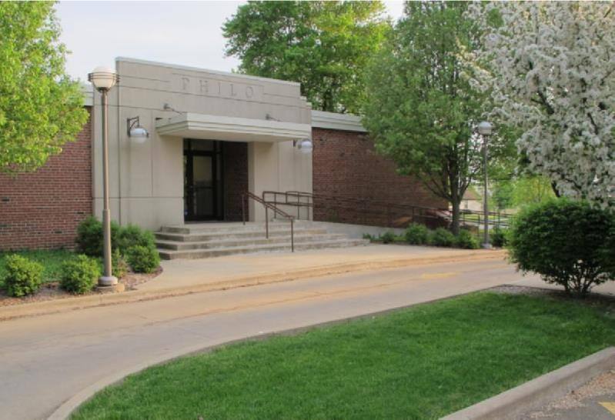

PRSRT STD
ECRWSS
U.S. POSTAGE
PAID
EDDM Retail

News from the Best

Little Town in
Illinois

Winter 2021-2022
December - February

Village of Philo

FROM THE VILLAGE PRESIDENT
By: Larry Franks
Another year is coming to an end and the Board of Trustees and I would like to wish you all well in the New Year.
Once again, the village received a fiscally healthy report card from our annual audit. The annual Treasurers Report has been posted and can be reviewed by the public.
Unfortunately, we were not able to get details worked out with the State to get our annual oil and chip work done this summer. There will be several road projects coming up in the future to help keep the roads in the village in good condition. The sidewalk projects are coming along at a good pace. We are happy to be able to give people a safer place to walk.
Our big project for the year has been locating grants and funds for the playground equipment at Hazen Park. I want to thank the Philo Kids’ Festival committee for their work on the Back A Brick fundraiser and putting on the fun Festival. We have purchased the playground equipment and work will begin over the winter and hope to have the equipment ready for next baseball season. Keep donating for the bricks to help raise money for the playground equipment and work.
Have a safe, healthy and happy holiday season!
Comments and suggestions regarding
The Philo Newsletter format
and content are welcome.
Village of Philo
Attn: Newsletter
P.O. Box 72
Philo, IL 61864
Phone: 684-2562 E-mail: janet@villageofphilo.com

IN OTHER VILLAGE HAPPENINGS
Notes from the meeting minutes:
August – Bids for drainage at Emerald Lane in Willow Run approved. Road work on Roosevelt postponed. Request for Dave Traxler to obtain bids for survey and sidewalks on North Harrison. New trees ordered for the village. Simplicity mower needs replaced. Treasurer reported the village could be eligible for approximately $190,000 in ARPA funds. Looking for custodial staff. High humidity effects on REFMC floor discussed.
September – Stan Feller presented audit findings. Eric Beckett appointed to the Zoning Board. Representative from Game Time presented options for playground equipment and instructions on obtaining $35,000 matching grant for Hazen Park playground. Back A Brick fundraiser introduced. Text changes to the Zoning ordinance regarding fences presented. Quotes for new John Deere mower reviewed and approved.
October – Harrison St. right-of-way survey completed. Discussion for Washington and Harrison St. repairs. Village awarded $9,000 Unsewered Communities Grant. Treasurer reported the Village received its first ARPA payment from the State. Trick-or-Treat hours set.
November -- Minutes will be approved at the December board meeting to be held Wednesday, December 8, 2021 in the Eileen Painter Room of the R. E. Franks Meeting Center with a special meeting time of 6:30pm.
Meeting minutes are posted on the Village web site www.villageofphilo.com under the About Philo-Village Board tab after they are approved at the following monthly meeting. The public is invited to attend meetings.
Extra Recycling
Please help keep the recycling center and surrounding area clean and neat. We know there is extra recycling around the holidays and have ordered extra recycling pickup and containers thru the middle of January 2022. Please do not leave anything outside of the recycling containers if they are full. This creates a wet, soggy, unsightly mess and added expense to the Village. Please come back later. You can make extra space by breaking down your boxes. As with every other industry, we have been told there is a worker shortage and they will do their best to provide the extra services.
BRUSH PICK-UP
Final brush pick-up for 2021 will be December 1. Brush pick-up will resume on April 1, 2022 weather permitting.
DO NOT PILE BRUSH IN ROAD OR ALLEYWAYS. KEEP IT ON YOUR PROPERTY AND AWAY FROM STORM DRAINS.
CHRISTMAS TREE PICK-UP
Tree pick-up will be on or around January 14 or January 18, 2022. Weather permitting.
If you have questions, please contact Dave Traxler at 684-2674.

Burning Regulations
Residents may burn leaves, sticks and other dry plant debris grown or generated in Philo in a safe manner during daylight hours. Please be considerate of smoke direction and neighbors. Some residents have health issues that are adversely affected by smoke.
Materials prohibited from burning: tires and garbage, including bones, meat, animal skin, feathers, entrails, organs, non-edible animal parts, grease, food and food by-products, coffee grounds, table scraps and similar materials per Ordinance 2008-545.
The village burn area is off-limits to the public. Please do not dispose of yard waste at the burn pile.
Snow Removal
When there are two or more inches of snow on village streets, residents living on Washington Street in the downtown area are asked to park in the alley between the hours of 12:00am and 6:00am so that the streets of Washington and Harrison can be plowed. Village maintenance also requests that anyone living in a cul-de-sac park in driveways or further off the road. Parking in the circle makes it too tight for the plow trucks to do a decent job.
Sledding!
The snow will be flying soon. Sledding on the hill at the water tower is at your own risk. Motorized vehicles of any kind are not allowed on the hill.

Exercise helps keep the
winter blues away!!

Exercise with Caution. It’s great that so many people in the community enjoy getting out and walking, running, biking or taking care of their pets. The winter months bring challenges of getting these activities in safely. When outside, wear reflective gear and bright colored clothing. If it is dark, along with the reflective gear, wear or carrying a light. Rules of the Road dictate that walkers and runners face oncoming traffic. When biking, follow the rules of going with traffic. If you are on a hill, be sure to move to the side of the road and possibly stop until the vehicle has passed. Always assume the driver does not see you. Unfortunately, in this day of distracted driving they probably do not. Drivers, PUT DOWN THE PHONES! The R. E. Franks Center is open Monday – Friday from 7:00am – 9:00am (no pets allowed).
Watch for Sign-Up Dates
The Philo Ball Park Association is looking forward to getting back in the “swing” of things next summer. Watch for sign-up information late January or early February. Visit our web site for more information. www.villageofphilo.com/parks
About Philo – Business Spotlight
Each quarter we would like to give students the chance to spotlight a local business. Please reach out if you would be interested in sharing your business with the community. Contact janet@villageofphilo.com The next deadline for submission will be February 9, 2022.

Our first submission was written by Lucy Kleiss, a 7th grader at St. Thomas School.

All about For the Love of Hair and Abby Rogers!

Abby is a small-business owner in Philo. She runs the hair salon For the Love of Hair. At home in southwest champaign, she enjoys gardening, playing the guitar, and playing her Nintendo switch, while hanging out with her two cats. She also loves plants.
For the Love of Hair is located in Philo near the Philo Tavern. Abby and her 4 employees recently celebrated their 13th year in business. It was remodeled two years ago, and Abby purchased the 115-year-old building. It features a new floor, expanded space, and of course, more plants. It is now complete with a cozier look and feeling of being at home.
They have three cosmetologists for your hair, a technician for your nails, and an esthetician for your skin. They offer multiple services including custom haircuts, colors, and styles, body waxing, facials, and manicures and pedicures.
Abby says her favorite part of owning a business is “Talking to people and being a part of the community” though she has negative views on paperwork! She also said she loves talking to the kids who come in, especially about video games!
Please stop by For the Love of Hair and meet Abby. You may even want to stay!

For the Love of Hair
For the Love of Hair (loveofhairshop.com)
110 W. Washington St.
Philo, IL 61864
(217) 552-4719

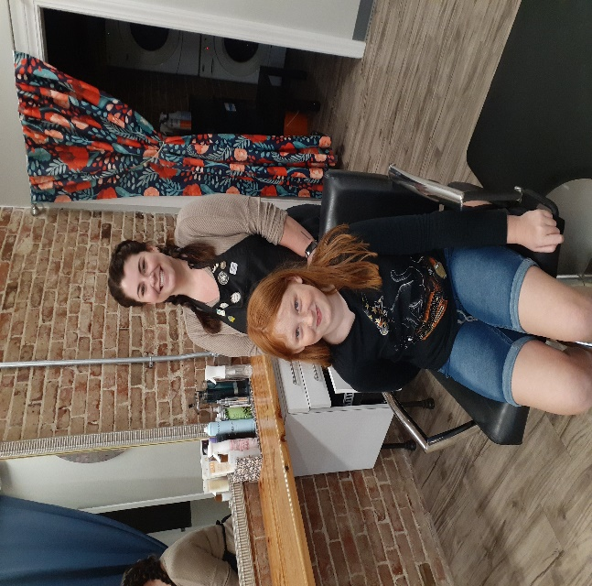

Lucy and Abby at For the Love of Hair

Meet the Trustee: David Happ
David was elected to the Village Board of Trustees in the April election of 2021. He will serve a 4-year term as Village Trustee.
As a lifelong resident of Philo with an interest in what makes the Village special, “I have a huge amount of respect for the people who have held Village office before me and that have kept Philo moving in the right direction.” David decided to run for Trustee to get a closer look at how things work and “hopefully” contribute something positive along the way.
When asked about what he enjoys most about Philo, he responded that his favorite thing is that it has a reputation for being safe and friendly. He loves to hear stories about people who have moved to town and immediately felt welcome. David enjoys the great local churches, strong businesses and especially close to his heart is St. Thomas School that has been around for over 100 years. “People who live and work in Philo are proud of their community and are always looking for ways to make it a better place.” He and his wife Lisa have twin daughters Brittany and Brooke. David is a transportation engineer with the City of Champaign. In his spare time, he enjoys being a math tutor, studying local history, baseball card collecting, following Illini sports and playing the banjo.

Philo Phlashbacks

A little bit of Philo history from the archives. Please let us know how you like this section and if you have something you would like to read about or submit.

December 1965
Two Champaign youths were caught inside O’Neill’s Tavern in Philo that had been burglarized early Wednesday and a third youth, who had allegedly broken into the tavern with the others, was caught later. Capture of the two men, Sheriff Everett Hedrick said, came after a woman called the county jail about 2:13 a.m., stating two men had broken into the tavern.
A special deputy, Harold Kirby, who lives close to the tavern, was notified and sheriff's patrol cars and State Police were alerted by radio. Kirby and Deputy Louis Munds arrived at the tavern at about the same time, Hedrick said, and started in the back door of the tavern as two suspects started out. The two jumped back inside and slammed the door, Hedrick said. One of the deputies then fired a 12-gauge riot gun once in the air over the door, which reaches nearly the top of the building, shouting “Come out or we’re coming in shooting.”
The two came out with their hands up. In a matter of minutes after receiving the call, Hedrick said, he arrived in a car as did five other sheriff's cars and two State Police cars. Sixteen other cars, eight regular sheriff’s cars and eight with special deputies were standing by within 5-½ minutes for setting up roadblocks if needed. One of the burglars, who is small, hid behind some boxes behind the door of the woman’s restroom and was not spotted during the tavern search. However, he was arrested on his arrival after walking from Philo to Urbana, Hedrick said.

December 1965
As many of the Philo residents have noticed by now, new “Yield” signs have been placed at various intersections of the town. Mr. Roy Jones posted these signs early last week. Approximately 65 signs were erected. These signs were purchased from the State Penitentiary and were made by the inmates.

December 1965
Ground was broken on Thanksgiving Day for construction of the new parish school of St. Thomas Catholic Church, Philo. The ceremony was conducted at 8:45 a.m. after the Thanksgiving Mass at 8 a.m. in the church. Rev. Fr. John C. Hecht is pastor. Plans provide for a four-room school with attached parish hall to be erected at a cost of approximately $129,000. Contracts for the project have been let, and it is hoped that footings can be set in the next month so that construction above ground can be started in the spring. The schedule calls for completion by August 1, 1966. Later in the winter bids will be received on building a convent to house four or five nuns.
The new school will replace an old building, which is overcrowded and in poor condition. It will be located on a site east of the present school, which eventually will be razed. Parishioners voted about a year ago to erect a new building which will provide for future growth as well as the present increased enrollment resulting from the growth of Philo’s population and other factors. St. Thomas School now has an enrollment of 110 as compared with less than 40 only about a decade ago. Two Dominican sisters from Springfield and one lay teacher are on the faculty.
Five members of the eighth grade graduating class of 1965 of the school turned the first earth as ground was broken, representing the generations of pupils who have attended St. Thomas and those who will be in future classes. The five were Patricia Cain, Maureen Grady and Edith McCormick, all of St. Thomas Parish; Alice Marie Hettinger of Immaculate Conception Parish, Bongard; and James Schaffer of St. Patrick’s Parish, Tolono. Wayne Bonnell, contractor, and church trustees Alvin Decker and Leo Clennon, also took part in the ceremony, assisted by the building committee, Gerald Fehrenbacher, John Grady, Otto Henry, John Keeler, Gene O’Neill, John Schumacher and George P. Porter.

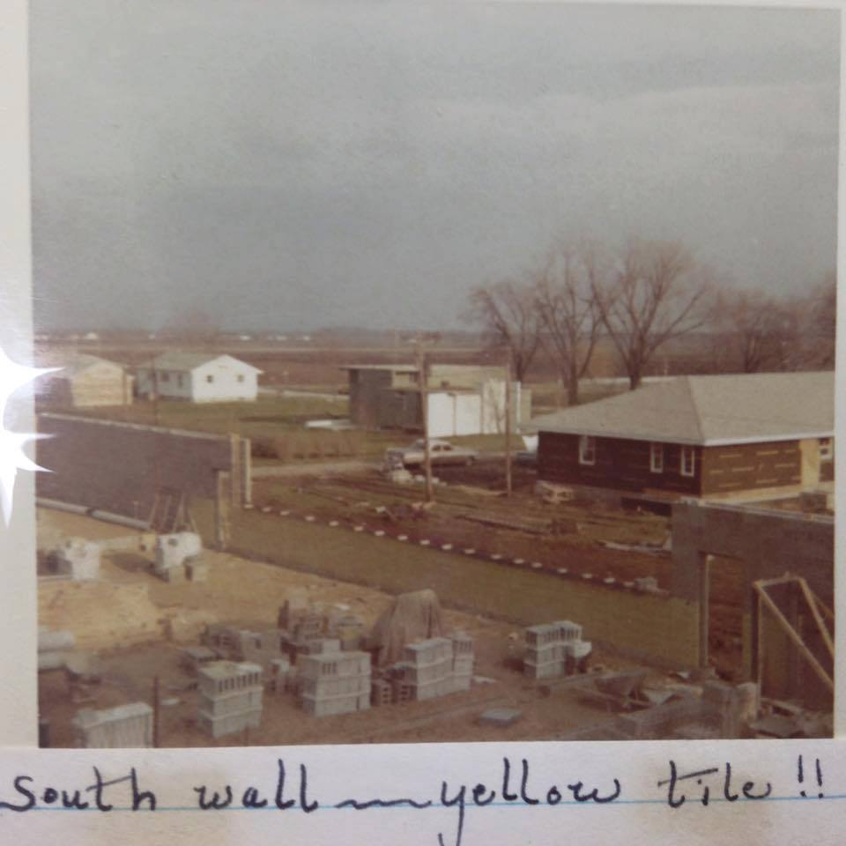

R. E. Franks Meeting Center Information
Dates are filling in fast for Spring and Summer 2022. If you have a special event coming up in the spring (i.e., graduation) please contact Janet Decker at (217) 684-2562 or e-mail janet@villageofphilo.com. Additional information and a calendar for availability can be found on the village web site www.villageofphilo.com under Franks Center tab.
The REFMC is looking for part-time event staff and custodians. Please contact the office or Dave Traxler if you or someone you know would be interested.

Clergy Corner
Zion Lutheran Church – Located at: 101 W. Van Buren St., Philo IL 61864
Zion Lutheran Church will recognize Advent beginning on Sunday, November 28 and each Sunday through Christmas Eve. Our weekly Sunday services are held at 8:30am. Sunday School meets weekly for children ages 3 and up during service.
A candlelight Christmas Eve service will be held on Friday, December 24 at 5:00pm
Looking ahead – an Ash Wednesday service will be March 2, 2022. There will also be weekly Lenten services. Follow our Facebook page for the most up to date information: https://www.facebook.com/ZionLutheranPhilo
St. Thomas Catholic Church and School – Parish office located at 310 E Madison St, PO Box 266, Philo, IL 61864
St. Thomas School students will be performing in their annual Children’s Christmas programs. PK - 2nd grade will perform on Sunday, December 5th at 2:00pm in the Robert H. Trost Gymnasium. Band and Choir students’ 3rd – 5th grade will perform on Wednesday evening, December 15 at 6:00pm in the Robert H. Trost Gymnasium.
You can find weekly and Holy Day Mass schedules on our web site at Saint Thomas Catholic Church | Philo, Illinois (stthomasphilo.org) You can also participate in our live stream Masses on our Facebook page at St. Thomas Catholic Church – Philo.
Santa Breakfast Is Back!
The annual Santa Breakfast hosted by the Philo Exchange Bank will be held this year on Saturday, December 4 from 9:00am – 11:00am at the R. E. Franks Center. Come enjoy donuts, games, gifts & Santa. Bring a toy donation for Toys for Tots and receive 10 free game tickets. Additional tickets are .25 cents each.
Annual Tree Trimming
Philo Township Library will be hosting their annual Ornament Workshop Sunday, December 5 from 3:00 – 4:00pm. From 4:00 – 5:00pm there will be caroling, decorating and lighting the Village tree behind the library. There will be cookies & hot chocolate after the lighting. Please join in the Philo tradition.
Warm Hearts, Warm Hands
Philo Exchange Bank will be collecting new gloves, hats, and warm socks for kids K-12th grade during the month of December as part of the Warm Hearts, Warm Hands drive. Donations received will be distributed to children in need at local schools.
LET’S HAVE A PARADE!
Come out and celebrate the 2nd Annual Village of Philo Christmas Parade on Friday, December 10. The parade begins at 7:00pm with 6:00pm lineup along Madison St. facing west. The parade will head south on Jackson, winding through town passing by Hazen Park and making its way back to Washington Street. See the village website for a map under the Announcements tab. You can download a parade entry form from the village web site or pick up a form from the bank, library or village office. Entries can be decorated golf carts, cars, trucks, etc. with lights and festive decorations! No Santa’s allowed – that will be reserved for the one and only Santa Claus who will appear at the end of the parade. Deadline is December 1.
Please be considerate of your Philo neighbors if parking on or near private property. Candy will be distributed; use caution when collecting it. The Philo Tavern will sell hot cocoa & cider curbside.

Upcoming Village Holiday Schedule

Office & Maintenance Closed on the following days:

Friday, December 24 (1/2 day) - Christmas Eve

Monday, December 27 – Christmas Observed

Friday, December 31 – New Year’s Day Observed

Monday, January 17 – Martin Luther King Birthday Observed

Monday, February 21 – Presidents Day Observed

Village Board and Officials
Village President  Larry R. Franks . (217) 377-1454  LRFranks11@yahoo.com  Village Clerk  Judy Kirby ............... (217) 684-2118  Village Treasurer  Kevin Chalmers………….(217) 441-2927  Trustees  Tom Kelley………369-6690.. tom.kelley@syngenta.com  David Happ............417-3128...Happs65@yahoo.com  Pat Pioletti............. 493-9069.. pw64@comcast.net  Paul Brady …….... 684-2540.. paul-brady@comcast.net  Rachael Garrett…. 714-8484.. rachaelgarrett@comcast.net  Steve Messman … 493-8762.messmanfarms@comcast.net  Village of Philo  127 W. Washington St.  P.O. Box 72  Philo, IL 61864-0072 | Village Deputy Clerk & R. E. Franks Meeting Center Rentals  Janet Decker.. 684-2562.. janet@villageofphilo.com  127 W. Washington St., Monday - Friday 8am - 11am  Village Maintenance & Building Inspector  David Traxler ............................................ 684-2674  105 E. Washington St., Monday-Friday 7am - 4 pm  Philo Planning Commission  Chris Payne, Co - Chair ............................... 684-2226  Karl Helmink, Co - Chair.......karl.helmink@comcast.net  ESDA Co-Coordinators  Richard Brand ...................................... 778-8259  PRSRT STD  ECRWSS  U.S. POSTAGE  PAID  EDDM Retail  Chris Lueth……..……………………..377-9627

*****************ECRWSS****
Local
Postal Customer

