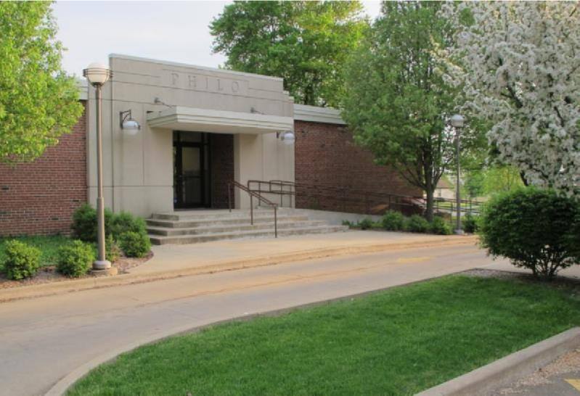

News from the Best

Little Town in
Illinois

Summer 2020
June - August

Village of Philo

FROM THE VILLAGE PRESIDENT
By: Larry Franks
First, I want to start off by saying THANK YOU to everyone who has continued to support our local businesses that were allowed to stay open on a limited basis. Also, THANK YOU to everyone who has stayed at home in an effort to slow down this virus, stay healthy and help keep their friends, families and neighbors healthy. The Board of Trustees and I receive daily updates from the governor’s office through our Illinois Municipal League partners and I have sat in on several phone calls with the governor and other municipal representatives in an effort to stay up-to-date on the situation and make the best decisions for our community.
Fiscally, the Village is currently in decent shape and should be able to ride this out. If you, your family or business needs assistance, please contact the Village office. There are resources available through the county, state and federal agencies.
We have had to conduct our last two monthly Board meetings through Zoom. This has worked out well and I want to thank everyone that has attended these meetings and expresses concerns and offered solutions on how to keep our community safe and a good place for families. Also, on behalf of the Village Board, I want to apologize for the misunderstanding of the issue with the golf cart ordinance and any inconvenience it may have caused. We work to keep the village safe for all residents and try to make the best decisions to do that. We welcome constructive comments from the community.
With the warm weather and so many people not able to go to their jobs the streets are pretty busy with people getting fresh air, make sure you are watching out for each other. Take care of your pet waste. SLOW DOWN on roadways, yield and proceed with caution at YIELD signs and come to a complete stop at STOP signs.

IN OTHER VILLAGE HAPPENINGS
From the meeting minutes:
March - Randa Plotner presented to the board as a recruiter in the area for Census 2020 Takers. Request for annexation of a 2 acre lot for single family residence was presented by Village Engineer. The Golf Cart Ordinance was discussed and voted in favor of amending. Concrete bids for the recycling area were presented by Village Maintenance. Discussion from Trustee Brady on how to improve the look of our downtown area.
March -- SPECIAL MEETING-- Mayor Franks called a special meeting of the Board of Trustees on March 20. The meeting was called after the Governor proclaimed the Stay At Home order for the State of Illinois. At the special meeting a Declaration of Emergency was issued. The Trustees voted to approve an ordinance granting the mayor emergency powers during the state of emergency. In an effort to continue the business of the Village, the Board voted to hold future meetings electronically through the Zoom format. Hugs & Bugs closed effective noon on March 20. The Board voted to prorate their rent through March and waive rent until they are allowed to reopen. Deputy Clerk Decker to work from home.
April - The village began holding meetings via Zoom. A Public Hearing was held to discuss annexation of 2+/- acres for single family home and sidewalk waiver. Annexation was approved and waiver was accepted for payment of $3,875. Village maintenance thanked the village for the new truck; the recycling bins have been relocated to allow for concrete pads to be poured; Clean-up day was cancelled due to the virus. A request from a resident for a ban on the village burning ordinance was discussed. No change to the ordinance was made.
May - Meeting was held via Zoom. Discussion regarding issues with the updated golf cart ordinance were discussed. Minutes on the web site after approval at the June meeting.

2020 Census Day
The U.S. Department of Commerce and U.S. Census Bureau began the 2020 Census count on April 1, 2020.
The U. S. Constitution (Article 1, Section 2) mandates a headcount every 10 years of everyone residing in the United States. It is the hope of the Trustees and Mayor Franks that every resident will comply with the census request. In 2000 we had a mail in participation rate of 89%, however that rate went down in 2004 to 84%. When you do not respond by mail, a census taker will follow up personally to collect the data. Census takers do not need a door-to-door permit, but they are required to carry identification. The census determines how many seats in Congress each state gets and helps determine how states and communities receive federal funding. Your participation counts!
Community Clean Up Day & Recycling
BRUSH PICK-UP
Brush pick-up continues and will run through December 1 weather permitting. Pick-ups are done on the 1st and 15th of each month. If those dates fall on a weekend or the weather does not cooperate, the pick-up will be the following Monday or next available day.
**Use paper bags for plant material 12 inches or smaller.
**Stack limbs that are 12 to 60 inches in length.
**Cut items that are longer than 60 inches.
**Cut wood limbs that are greater than 6 inches in diameter into 3 foot or less length pieces and separate.
DO NOT PILE BRUSH IN ROAD OR ALLEYWAYS. KEEP IT ON YOUR PROPERTY AND AWAY FROM STORM DRAINS.
If you have questions, please contact Dave Traxler at 684-2674.
The Village Board voted to cancel the spring Community Clean-Up & Recycling day due to the virus and stay at home orders in place. The fall event is still on schedule for October.

Recycling Area
Effective June 1 the recycling bins will be returned to the recycling area under the water tower. Please help keep the recycling area clean and free of debris. This is a free service to Village and Township residents. When items are left outside of the dumpsters they become an extra expense for the village to clean up. If there is not space in the dumpsters, come back another day. The dumpsters are usually delivered on Monday & Wednesday on alternating basis.

Exercise with Caution
It’s great that so many people in the community enjoy getting out walking, running, biking or taking care of their pets. When it is dark, wear reflective gear, bright colored clothing and wear or carry a light. Rules of the Road dictate that walkers and runners face oncoming traffic. When biking, follow the rules of going with traffic. If you are on a hill, be sure to move to the side of the road and possibly stop until the vehicle has passed. Always assume the driver does not see you. Unfortunately, in this day of distracted driving they probably do not. Drivers, PUT DOWN THE PHONES & watch your speed! Walking at the R. E. Franks Center is currently suspended.
Brick sidewalk repairs are coming to a neighborhood near you. Watch the web site for meetings regarding sidewalks for the Village of Philo!

COMING SOON
Philo Kids’ Festival -- Mark your calendars and watch for further details -- Saturday, August 22! The Philo Kids’ Festival committee is planning to hold the festival again this year to raise funds for village playground equipment. You can follow them on Facebook at Philo Kids’ Festival.

*UPDATE* Golf Cart Registration & ATV Use
Due to wording issues in the golf cart ordinance that was updated at the March 11 meeting, the ordinance will be amended and brought to the June Board of Trustees meeting for review and vote. The intention of the Board was to update the ordinance to change and clarify some of the regulations. The addition of ATV’s and/or other off-road vehicles was not intended.
Open alcohol and/or drinking and driving are illegal.

**Only inspected golf carts are allowed on the Village streets when being operated by a licensed driver 16 years or older.
**Qualifying golf carts must have a maximum attainable speed of 20 miles per hour and be properly equipped. Any person who operates a golf cart must possess a valid driver’s license and insurance coverage. The maximum occupancy in the cart is one person per bucket seat or two people per bench seat.
**Golf carts can be driven on streets after dark, only with proper qualifying equipment (headlights; taillights; signals; slow moving emblem).
**The biennial permit fee is $50. A new sticker will be issued at renewal. The renewal date is May 1.
**Golf cart inspection appointments may be made with Trustee Paul Brady at paul-brady@comcast.net, by phone at 684-2540 or by calling the village office at 684-2562.
ATV’s and other off-road vehicles are NOT allowed on Village streets or properties, this includes the hill and drainage pond area.
Violations are punishable by a fine of not less than $100 or more than $500 for each violation.
You can read the ordinance and print off an application on our village website under the ABOUT PHILO/Ordinances tab or contact the office Monday through Friday from 8:00am to 11:00am. You may call 684-2562 or e-mail inquiries to janet@villageofphilo.com.

Did You Know:
Aqua Illinois is the water provider for the Village of Philo. They are responsible for water turn on/off and the primary source for boil order notifications. They can be reached at 877-987-2782 to set up notifications to your phone or email.

Frequent Inquiries and Ordinances
We frequently have inquiries from residents about certain rules and regulations. The Frequently Requested ordinances can be found on the village web site under ABOUT PHILO/Ordinances and should be “searchable”. Not all village ordinances have been uploaded to the web site at this time. Listed here are the most common topics for this time of year:
- Zoning - Ordinance #2018-622
  - Fences -- Yes, permits are required. Contact Dave Traxler at 684-2674 / 840-3861 or email dtraxler@villageofphilo.org for permit and more information.
- Pools -- a permit is not required for pools, however, pools meeting certain height restrictions require a fence. (Ordinance #2018-622, Article 8- Fencing and Buffers)
- The village does not have a catch all “nuisance” ordinance, however there are ordinances on the books for:
  - Burning of Materials #2008-545
  - Construction Hours #2005-529
  - Animal Control #2014-586,
  - Plants & Weeds #1973- 194,
  - Garbage and Debris #1974-201
  - Livestock restrictions #2018-622
  - Door-to-Door #1981-306
If you have a question or cannot locate the information you are looking for, please feel free to contact the office.

Board Meetings and Communication
Monthly Board meetings are held on the 2nd Wednesday of every month at 7:00pm in the R. E. Franks Meeting Center. The exception is the December meeting which is held at 6:30pm. The public is invited to attend. Meeting notices are posted on the electronic sign. Notices, along with the agenda are posted at the north entrance bulletin board of the R. E. Franks Center, the main bank vestibule bulletin board, the post office and on the village web site. All Trustee’s contact information is included in the Newsletter and can also be located on the village web site. Trustee positions are for 3 years; the next election will be held in March 2021. Village communications are not handled through Facebook Philo Watch. Occasionally, we use the page for time sensitive information.

Village Board and Officials
Village President  Larry R. Franks ..... 377-1454.. LRFranks11@yahoo.com  Village Clerk  Judy Kirby ............... 684-2118  Village Treasurer  Kevin Chalmers………….(217) 441-2927  Trustees  Tom Kelley….. ….. 369-6690.. tom.kelley@syngenta.com  Steve Sappenfield.. 621-3084.. Steve@philosports.com  Pat Pioletti............. 493-9069.. pw64@comcast.net  Paul Brady ……..... 684-2540.. paul-brady@comcast.net  Rachael Garrett…. 714-8484.. rachaelgarrett@comcast.net  Steve Messman … 493-8762.messmanfarms@comcast.net | Deputy Village Clerk & R. E. Franks Meeting Center Rentals  Janet Decker.. 684-2562.. janet@villageofphilo.com  127 W. Washington St., Monday - Friday 8am - 11am  Village Maintenance & Building Inspector  David Traxler …………….......... 684-2674/840-3861 105 E. Washington St., Monday-Friday 7am - 4 pm  Philo Planning Commission  Chris Payne, Co - Chair ............................... 684-2226  Karl Helmink, Co - Chair.......karl.helmink@comcast.net  ESDA Co-Coordinators  Richard Brand ...................................... 778-8259  Chris Lueth……………………………………………..377-9627

View meeting agendas & minutes on the Web at www.villageofphilo.com

PRSRT STD
ECRWSS
U.S. POSTAGE
PAID
EDDM Retail

Village of Philo
127 W. Washington St.
P.O. Box 72
Philo, IL 61864-0072

*****************ECRWSS****
Local
Postal Customer

