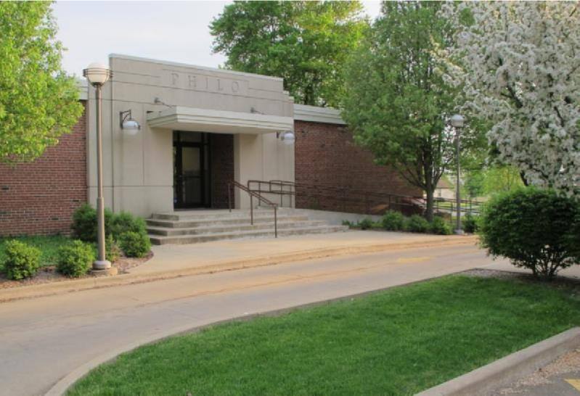

News from the Best

Little Town in
Illinois

Spring 2020
March - May

Village of Philo

FROM THE VILLAGE PRESIDENT
By: Larry Franks
I want to thank everyone that comes to our board meetings and expresses concerns and offers solutions on how to keep our community safe and a good place for families. There are a lot of good events coming up to help support the community and the schools.
With the warm weather coming, make sure you are watching for walkers and runners. Take care of your pet waste. Slow down on roadways, and stop at signs. The village trustees are working on updating the ordinance pertaining to golf carts. Contact Janet if you have a golf cart and need to get it registered or renew your registration.

IN OTHER VILLAGE HAPPENINGS
From the meeting minutes:
December - Further discussion regarding St. Thomas parking along Garfield. Ordinance passed for Regular Monthly Meeting Dates for the Board of Trustees. Motion passed to purchase 2019 GMC and snow plow for the Village Maintenance. Contract with Hugs & Bugs Daycare renewed. Survey sent to all Village residents regarding IL Cannabis Regulation and Tax Act. Bob Daly requested long term raffle permit. The R. E. Franks Center has updated Wi-Fi system and equipment.
January - Public information meeting was held prior to the Board meeting to hear further input from the community regarding regulating cannabis businesses. Nineteen residents came to the meeting. Mayor Franks noted the good turn-out considering Savoy only had four people and Urbana had twelve. The survey results were distributed. Approximately 700 surveys were mailed out; 80 were returned. The results were overwhelmingly against allowing retail sale, processing and growing of cannabis in the Village of Philo. At the Board meeting Bob Daly was informed by the Village attorney that he would be

required by the State to obtain a new license for every raffle held. Concern expressed regarding Garfield being so narrow on the East side of St. Thomas. 2019 GMC truck we were to purchase was sold, but Warden Martin to honor the quoted price for a 2020. Truck to be here mid-March. Discussions on how to clean up and fix the recycling area. Entrance rugs and cleaning bids presented for R. E. Franks Center. Board is considering selling the Old Village Hall at 120 W. Washington. An appraisal is needed. St. Thomas gymnasium was dedicated.
February - Discussion to update the golf cart ordinance. The ordinance to prohibit cannabis businesses was passed unanimously.
Meeting minutes are posted on the Village web site www.villageofphilo.com under the About Philo-Village Board tab after they are approved at the following monthly meeting. The public is invited to attend meetings.

2020 Census Day
The U.S. Department of Commerce and U.S. Census Bureau will begin the 2020 Census count on April 1, 2020. The U. S. Constitution (Article 1, Section 2) mandates a headcount every 10 years of everyone residing in the United States. It is the hope of the Trustees and Mayor Franks that every resident will comply with the census request. In 2000 we had a mail participation rate of 89%, however that rate went down in 2004 to 84%. When you do not respond by mail, a census taker will follow up personally to collect the data. Census takers do not need a door-to-door permit, but they are required to carry identification.

Fire Department Seeks Volunteers
The Village of Philo fire department is currently seeking volunteers for the department. Please contact the village office (684-2562) for Fire Department contact information.
American Legion is looking for Members
Are you a veteran? Did you know the Village of Philo has an American Legion and are looking for new members? They meet monthly on the 3rd Tuesday of the month at 6:30pm in the Township Building on Harrison Street.
BRUSH PICK-UP
Brush pick-up will resume on Monday, April 1, 2020 and run through December 1 weather permitting. Pick-ups are done on the 1st and 15th of each month. If those dates fall on a weekend or the weather does not cooperate, the pick-up will be the following Monday or next available day.
**Use paper bags for plant material 12 inches or smaller.
**Stack limbs that are 12 to 60 inches in length.
**Cut items that are longer than 60 inches.
**Cut wood limbs that are greater than 6 inches in diameter into 3 foot or less length pieces and separate.
DO NOT PILE BRUSH IN ROAD OR ALLEYWAYS. KEEP IT ON YOUR PROPERTY AND AWAY FROM STORM DRAINS.
If you have questions, please contact Dave Traxler at 684-2674.
Community Clean Up Day & Recycling
Once again the village will provide dumpsters and a recycling service for the Community Clean-Up Day on Saturday, May 9, 2020 for residents of the Village of Philo. This is a free service provided to Village residents only and is an honors system program that we hope people use with respect. The Village will host another day in the fall.
Locust Grove Cemetery Clean Up
The Locust Grove Cemetery Board requests help cleaning up the cemetery as soon as possible to prepare for the coming warmer months of mowing.

Recycling Area
Please help keep the recycling area under the water tower free of debris. This is a free service to Village and Township residents. When items are left outside of the dumpsters they become an extra expense for the village to clean up. If there is not space in the dumpsters, please come back another day. The dumpsters are usually delivered on Monday & Wednesday on alternating basis. The Trustees are in the process of coming up with a plan to help clean up the area.
Household Hazardous Waste Collection
Champaign County Recycling is hosting and event on Saturday, April 4, 2020 from 8:00am - 3:00pm. You must call (217) 819-4127 or visit the web site at hhwevent.simplybook.me to register to participate in this event. You will be turned away if you do not have a reservation. Locations are listed on the registration web
site.
Exercise with Caution
It’s great that so many people in the community enjoy getting out and walking, running, biking or taking care of their pets. When dark, wear reflective gear, bright colored clothing and wear or carry a light. Rules of the Road dictate that walkers and runners face oncoming traffic. When biking follow the rules of going with traffic. If you are on a hill, be sure to move to the side of the road and possibly stop until the vehicle has passed. Always assume the driver does not see you. Unfortunately, in this day of distracted driving they probably do not. Drivers, PUT DOWN THE PHONES! Walking at the R. E. Franks Center from 8:00am - 9:00am, Monday - Friday is always an option (no pets allowed).
Election Day -- Tuesday
March 17, 2020

Election Night Stag
Philo Knights of Columbus will be bringing back the Election Night Stag on Tuesday, March 17 from 6:00pm - Midnight. Cover charge at the door. Food, drinks and gambling. K of C Hall; 108 S. Harrison St.
Charitable Games #029349

*UPDATE* Golf Cart Registration & ATV Use Pending approval at the March 2020 Board of Trustees Meeting the following are some of the current regulations and proposed changes -- Village Trustees remind residents that the use of ATV’s, motorbikes, golf carts without permits and other off-road vehicles are not allowed on village streets, parks, ball diamonds, the hill and other Village properties.
**Only inspected golf carts are allowed on the Village streets when being operated by a licensed driver 16 years or older.
**Qualifying golf carts must have a maximum attainable speed of 20 miles per hour and be properly equipped. Any person who operates a golf cart must possess a valid driver’s license and insurance coverage. The maximum occupancy in the cart is one person per bucket seat or two people per bench seat.
**Golf carts can be driven on streets after dark, only with proper qualifying equipment (headlights; taillights; signals; slow moving emblem).
**The biennial permit fee is $50. A new sticker will be issued at renewal. The renewal date is May 1.
**Golf cart inspection appointments may be made with Trustee Paul Brady at paul-brady@comcast.net, by phone at 684-2540 or by calling the village office at 684-2562.
ATV’s and other off-road vehicles are NOT allowed on Village streets or properties this includes the hill and drainage pond area.
Violations are punishable by a fine of not less than $100 or more than $500 for each violation.
The ordinance and complete list of requirements is available at the Philo Village Office inside the R. E. Franks Meeting Center at 127 West Washington Street. Office hours are Monday through Friday from 8:00am to 11:00am. You may call 684-2562 or e-mail inquiries to janet@villageofphilo.com.

R. E. Franks Meeting Center Available for All Celebrations and Activities
Are you looking for a facility for your family holiday gatherings? This is a great venue for family reunions, holiday celebrations, graduation parties, kids’ birthday parties and celebration of life events. It is also available to rent for pick-up basketball games or other activities. Philo resident rate is $22.50 per hour. Additional information and a calendar for availability can be found on the village web site www.villageofphilo.com under Franks Center tab. Contact Janet Decker at 684-2562 or e-mail janet@villageofphilo.com to reserve your date.
Dates To Watch:

Philo Knights of Columbus Friday Fish Fry
Philo Knights of Columbus will be hosting their traditional Lenten Fish Fry Dinners in the John Schumacher Gym at St. Thomas School every Friday in March and the first Friday in April at 6:30pm - March 6, 13, 20, 27 & April 3. Enjoy a delicious fried cod sandwich, sides, drinks and dessert. The adult meal is $8; Kid’s Mac & Cheese meal is $2, adult Mac & Cheese available for $5.

Philo Fire Department - O’Philo Fest
Philo Fire Department and the Philo Tavern presents O’Philo Fest Sunday, March 15, 2020 from 2:00 - 6:00pm serving corned beef & cabbage. All proceeds benefit the Philo Volunteer Firemen.

Summer Ball Fundraiser
Saturday, April 4, 2020 from 5:00 - 8:00pm The Philo Summer Ball committee is once again hosting a gun raffle to raise funds for the summer ball sports program. Tickets are still available. Please visit their web site at https://philosports.com/philo-ball-park-gun-raffle-fundraiser for full details.

Philo Country Music Show at the REMFC
On Sunday, April 5, 2020 at 3:00pm, the Philo Country Music show will be hosted by Ed Clem and Chrissy Sparks, Special Guest: Dennis Stroughmatt on fiddle & vocals. Their Branson-style live music stage show is held at the R.E. Franks Meeting Center, 108 W. Madison Street in Philo. Tickets are $10 per person at the door. Concessions are available.

Easter Egg Hunt -- NEW TIME & LOCATION!
The annual Easter Egg Hunt sponsored by Philo 4-H Friends will be held 11:00am on Saturday, April 11, 2020 at Hale Park in Philo. All youth 5th grade and younger are welcome. Bring your own basket and camera for pictures with the Easter Bunny and Touch a Truck. This event is free and open to the public.

COMING SOON
Philo Kids Festival -- Mark your calendars and watch for further details -- Saturday, August 22.

Village Board and Officials
Village President  Larry R. Franks ..... 684-2493.. LRFranks11@yahoo.com  Village Clerk  Judy Kirby ............... 684-2118  Village Treasurer  Kevin Chalmers………….(217) 441-2927  Trustees  Tom Kelley….. ….. 369-6690.. tom.kelley@syngenta.com  Steve Sappenfield.. 621-3084.. Steve@philosports.com  Pat Pioletti............. 493-9069.. pw64@comcast.net  Paul Brady ……..... 684-2540.. paul-brady@comcast.net  Rachael Garrett…. 714-8484.. rachaelgarrett@comcast.net  Steve Messman … 493-8762.messmanfarms@comcast.net | Deputy Village Clerk & R. E. Franks Meeting Center Rentals  Janet Decker.. 684-2562.. janet@villageofphilo.com  127 W. Washington St., Monday - Friday 8am - 11am  Village Maintenance & Building Inspector  David Traxler .......................................... 684-2674 105 E. Washington St., Monday-Friday 7am - 4 pm  Philo Planning Commission  Chris Payne, Co - Chair ............................... 684-2226  Karl Helmink, Co - Chair.......karl.helmink@comcast.net  ESDA Co-Coordinators  Richard Brand ...................................... 778-8259  Chris Lueth……………………………………………..377-9627

View meeting agendas & minutes on the Web at www.villageofphilo.com

PRSRT STD
ECRWSS
U.S. POSTAGE
PAID
EDDM Retail

Village of Philo
127 W. Washington St.
P.O. Box 72
Philo, IL 61864-0072

*****************ECRWSS****
Local
Postal Customer

