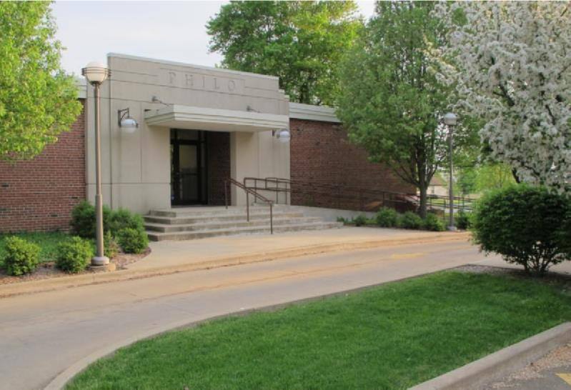

News from the Best

Little Town in
Illinois

Winter 2019-2020
December - February

Village of Philo

FROM THE VILLAGE PRESIDENT
By: Larry Franks
Another year is coming to an end and the Board of Trustees and I would like to wish you all well in the New Year.
This year was filled with sadness and joy for the Village. We lost a strong supporter of our community with the death of John Mumma and his wife Brenda. However, we saw the community come together in celebration with the Philo Kids Festival to raise money for new playgrounds at our parks. Unfortunately, we did not get the grant we were hoping for this year. We will continue to look for ways to raise funds to improve our community
I want to remind everyone whether you are out for a run, walk or walking your pet to please wear light or reflective gear now that it gets dark so early. Also, the number one complaint I received this year is speeding and disobeying stop signs. Please SLOW DOWN AND OBEY STOP SIGNS.
Have a safe and happy holiday season!

IN OTHER VILLAGE HAPPENINGS
From the meeting minutes:
September - The annual audit was completed and presented to the Board. All good news. Assets are up and statement looks good. Village Engineer Dave Atchley continues to work with St. Thomas on the addition and parking lot. Honorary Street Naming Rights Proposal was reviewed. Trustee Sappenfield presented the Board with a review of the Park Association account balances and income/expenses.
October - Updates for St. Thomas parking continues. Dave T. presented a quote for new village pick-up truck. Honorary Street Name Ordinance approved. Village administrative office technology update quote

presented by Janet Decker from Area Wide. Ball park drainage work completed. Re-seeding of retention pond completed. Discussion of hemp dispensaries and importance of public hearing.
November - Minutes will be approved at the December board meeting to be held Wednesday, December 11, 2019 in the Eileen Painter Room of the R. E. Franks Meeting Center with a special meeting time of 6:30pm.

Meeting minutes are posted on the Village web site www.villageofphilo.com under the About Philo-Village Board tab after they are approved at the following monthly meeting. The public is invited to attend.
CHRISTMAS TREE PICK-UP
Tree pick-up will be January 13, 2019 with final pick-up on January 17, 2020. Weather permitting.
BRUSH PICK-UP
Final brush pick-up for 2019 will be December 2. Brush pick-up will resume on Monday, April 1, 2020 weather permitting.
DO NOT PILE BRUSH IN ROAD OR ALLEYWAYS. KEEP IT ON YOUR PROPERTY AND AWAY FROM STORM DRAINS.
If you have questions, please contact Dave Traxler at 684-2674.

Community Clean Up Day & Recycling
Once again the village provided dumpsters and a recycling service for the Community Clean Up day on October 6 for residents of the Village of Philo. This is a free service provided to Village residents only and is an honors system program that we hope people use with respect. Residents filled 7 dumpsters and 3 trailers for recycling. The Village will host another day in the spring.

Golf Cart Registration & ATV Use
Many golf carts are equipped for year-round use. Village Trustees remind residents that the use of ATV’s, motorbikes, golf carts without permits and other off-road vehicles are not allowed on village streets, parks, ball diamonds, the hill and other Village properties. Only inspected golf carts are allowed on the Village streets when being operated by a licensed driver 18 years or older. Per a 2009 ordinance, individuals who intend to drive their golf carts on Village streets must obtain a permit from the Village and have their carts inspected, among other criteria.
**Qualifying golf carts must have a maximum attainable speed of 20 miles per hour and be properly equipped. **Any person who operates a golf cart must be at least 18 years of age and possess a valid driver’s license and insurance coverage. The maximum occupancy in the cart is one person per bucket seat or two people per bench seat.
**Golf carts are to be driven on streets only and from sunrise to sunset.
**The annual permit fee is $15 for citizens ages 65 years and older and $30 for all others.
**Golf cart inspection appointments may be made with Trustee Paul Brady at paul-brady@comcast.net or by phone at 684-2540.

ATV’s and other off-road vehicles are NOT allowed on Village streets or properties this includes the hill and drainage pond area.

Violations are punishable by a fine of not less than $100 or more than $500 for each violation.
The ordinance and complete list of requirements is available at the Philo Village Office inside the R. E. Franks Meeting Center at 127 West Washington Street. Office hours are Monday through Friday from 8:00am to 11:00am. You may call 684-2562 or e-mail inquiries to janet@villageofphilo.com.

Exercise helps keep the
Winter Blues away!!

Exercise with Caution
It’s great that so many people in the community enjoy getting out and walking, running, biking or taking care of their pets. The winter months bring challenges of getting these activities in safely. When outside, wear reflective gear and bright colored clothing. If it is dark, along with the reflective gear, wear or carrying a light. Rules of the Road dictate that walkers and runners face oncoming traffic. When biking follow the rules of going with traffic. If you are on a hill, be sure to move to the side of the road and possibly stop until the vehicle has passed. Always assume the driver does not see you. Unfortunately, in this day of distracted driving they probably do not. Drivers, PUT DOWN THE PHONES! Walking at the R. E. Franks Center from 8:00am - 9:00am, Monday - Friday is always an option (no pets allowed).

Honorary Street Signs
At the October meeting the Board of Trustees voted on an ordinance that allows for naming a street or portion of a street in honor of a person or persons that have made significant contribution to the village of Philo. The Ordinance (2019-631) can be viewed on line at www.villageofphilo.com. Applications can be printed from the web site or obtained from the village office. The annual submission deadline is December 31.

Cannabis Public Opinion Survey/Hearing
With the new laws set to take effect on January 1, 2020, the Trustees are looking for guidance from the community on whether to allow the many aspects related to cannabis growth, retail, transport and use. There will be a survey mailed to all residents in late December with a public hearing held on January 8, 2020 prior to the monthly meeting. This is your opportunity to offer your opinion on this very important matter.

Many Holiday Activities Coming Up. Check out the enclosed Calendar of Events!

Philo Country Music Show at the
R. E. Franks Center
On Sunday, December 8, 2019 at 3:00pm, the Philo Country Music show will be hosted by Ed Clem and Chrissy Sparks, Special Guest: Dennis Stroughmatt on fiddle & vocals; featuring Darrel Cummings on guitar, and vocals; Dave Ohlsson, drums and vocals. Their Branson-style live music stage show is held at the R.E. Franks Meeting Center, 108 W. Madison Street in Philo. Tickets are $10 per person at the door. Concessions are available.

Extra Recycling
Please help keep the town and surrounding area clean and neat. We know there is extra garbage and recycling around the holidays and have ordered extra recycling pickup and containers thru the middle of January 2019. Please do not leave anything outside of the recycling containers if they are full. This creates a wet, soggy, unsightly mess and added expense to the Village. Please come back later.

Snow Removal
When there are two or more inches of snow on village streets, residents living on Washington Street in the downtown area are asked to park in the alley between the hours of 12:00am and 6:00am so that the streets of Washington and Harrison can be plowed. Village maintenance also requests that anyone living in a cul-de-sac park in driveways or further off the road. Parking in the circle makes it too tight for the plow trucks to do a decent job.

Comments and suggestions regarding
The Philo Newsletter’s format
and content are welcome.
Village of Philo
Attn: Newsletter
P.O. Box 72
Philo, IL 61864
Phone: 684-2562 E-mail: janet@villageofphilo.com

Santa Breakfast
The annual Santa Breakfast hosted by the Philo Exchange Bank will be held Saturday, December 7 at the R. E. Franks Meeting Center. Doors will open at 9:00 a.m. Breakfast is free and includes donuts, juice, milk and coffee will be available. There will be games, crafts, and photos with Santa. Each game will require 1 or 2 tickets and can be purchased for .25 each. Please bring a new, unopened toy and you will receive 10 free tickets.

Annual Tree Trimming & Lighting at the Library
The library will be having its annual ornament workshop on Sunday, December 8 from 3:00 - 4:00pm. The tree trimming and lighting ceremony will follow. Everyone is invited to stay for refreshments in the library after the lighting.

R. E. Franks Meeting Center Available for All Celebrations and Activities
Are you looking for a facility for your family holiday gatherings? This is a great venue for family reunions, holiday celebrations, graduation parties, kids’ birthday parties and celebration of life events. It is also available to rent for pick-up basketball games or other activities. If you need a venue for your celebration or family gathering, or to get the kids out of the house during winter break contact Janet Decker at 684-2562 or e-mail janet@villageofphilo.com. Philo resident rate is $22.50 per hour. Additional information and a calendar for availability can be found on the village web site www.villageofphilo.com under Franks Center tab.

Watch for Sign-Up Dates
Summer ball sign-up dates set for February 8, 9:00am - 11:00am & February 12, 6:00pm - 8:00pm at the Township Building on Harrison St. Online registration will be available beginning February 1, 2020. Visit our web site www.villageofphilo.com/parks for summer ball sign-ups.

Village Board and Officials
Village President  Larry R. Franks ..... 684-2493.. LRFranks11@yahoo.com  Village Clerk  Judy Kirby ............... 684-2118  Village Treasurer  Kevin Chalmers………….(217) 441-2927  Trustees  Tom Kelley….. ….. 369-6690.. tom.kelley@syngenta.com  Steve Sappenfield.. 621-3084.. Steve@philosports.com  Pat Pioletti............. 493-9069.. pw64@comcast.net  Paul Brady ……..... 684-2540.. paul-brady@comcast.net  Rachael Garrett…. 714-8484.. rachaelgarrett@comcast.net  Steve Messman … 493-8762.messmanfarms@comcast.net | Deputy Village Clerk & R. E. Franks Meeting Center Rentals  Janet Decker.. 684-2562.. janet@villageofphilo.com  127 W. Washington St., Monday - Friday 8am - 11am  Village Maintenance & Building Inspector  David Traxler .......................................... 684-2674 105 E. Washington St., Monday-Friday 7am - 4 pm  Philo Planning Commission  Chris Payne, Co - Chair ............................... 684-2226  Karl Helmink, Co - Chair.......karl.helmink@comcast.net  ESDA Co-Coordinators  Richard Brand ...................................... 778-8259  Chris Lueth……………………………………………..377-9627

View meeting agendas & minutes on the Web at www.villageofphilo.com

PRSRT STD
ECRWSS
U.S. POSTAGE
PAID
EDDM Retail

Village of Philo
127 W. Washington St.
P.O. Box 72
Philo, IL 61864-0072

*****************ECRWSS****
Local
Postal Customer

