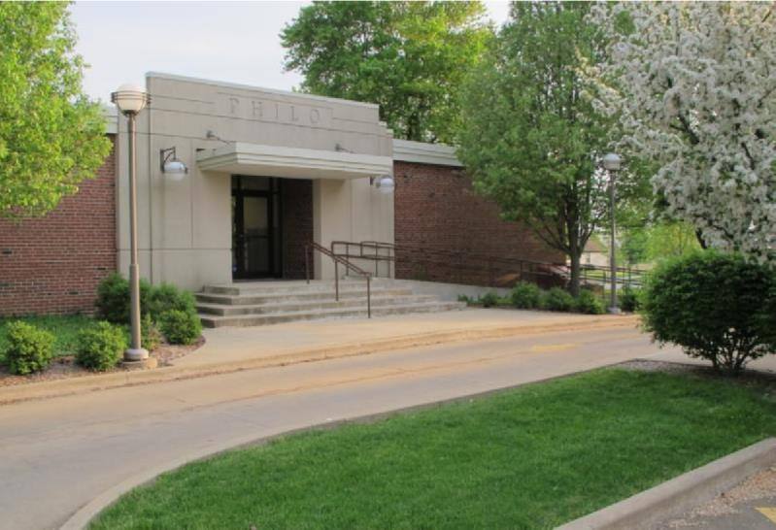

News from the Best

Little Town in
Illinois

Fall - 2019

Village of Philo

FROM THE VILLAGE PRESIDENT
By: Larry Franks

On behalf of the Village Board and personally, I want to thank the Philo Kid’s Festival Committee for the event they put together on August 17 to raise money for new playground equipment at our parks. The weather did finally cooperate and the Festival went on. The Village Board continues to look for ways to raise money for playground equipment and look forward to continuing to work with the Philo Kid’s Festival Committee.

The St. Thomas addition is moving along and our Village Engineer is working with the contractor and school administrators to make sure the building is compliance with village regulations. The Village Board toured the new addition on Monday, August 19.

A repeat topic of discussion that I have with residents is speed limits and stop signs. Please slow down when driving through the village and watch for kids and pets. New stop signs are rarely the answer. The speed limits are posted. School is back in session so kids are walking to and from bus stops; the weather is getting nicer and there will be more people out exercising. Please pay attention while driving.

Village Board meetings are held on the 2nd Wednesday of each month at 7:00pm. All meetings are open to the public and attendance is encouraged. The agenda is posted on our web page, the post office, main bank and the library. If you have a topic to be discussed, please contact the office 72 hours in advance of the meeting to be added to the agenda.

Watch for slow moving equipment as we get into harvest season. Have a great fall!

GO ROCKETS!

From the Monthly Meeting Minutes:

May ~ 2019-2020 Fiscal year for the Village begins. Three trustees Steve Messman, Rachael Garrett and Paul Brady were sworn in after re-election. Tom Kelley appointed to Village Board to fill vacant seat of John Mumma. Discussion concerning parking around St. Thomas Church and School. Drainage discussions for several areas of town due to spring rains.
June ~ Sidewalk repair downtown. New mower used on hill for first time, worked great. Re-seeding of hill discussed and clean-up of recycling area. Dollar General erosion revisited.
July ~ Run4Raley update. Greg Crowe from MSA presented information for OSLA grant for park/playground equipment. Board approved application. Village Attorney updated Board on OMA & FOIA request guidelines and requirements. The 2019-2020 Appropriations Ordinance passed unanimously. REFMC renovations discussed. Approval for purchase of podium. Request for stop sign at Jefferson & Cleveland denied. Shipley Estates signs to be removed. Golf Cart Ordinance tabled until late fall. Committee established to review Honorary Street/Building Naming.
August ~ Meeting held August 14. Minutes will be reviewed at September 8 meeting.

Approved minutes can be found on the Village web site. Agenda’s for the monthly meetings are posted 48 hours prior to said meeting on the Village web site.

Village Wide Garage Sale
The dates for the Village wide garage sale are set for Friday, September 27 & Saturday, September 28. These are the advertised dates. You are allowed to host your sale at a date and time convenient for you. There will be printed maps with addresses available at the post office, library, gas stations and village office. If you would like to be listed on the map, please contact Janet at 684-2562 or janet@villageofphilo.com. There is a $5 fee to help offset the cost of publishing/advertising.

Community Clean-Up Day & Recycling
The fall Community Clean-Up Day (Dumpster Day) & Recycling will be held on Saturday, October 5 from 7:00am - Noon at the corner of Adams & Washington St. This event is open to Village residents only.

Trick or Treat Hours Set
Trick or Treat hours in the Village of Philo will be from 6:00 - 8:00pm on Thursday, October 31. Remember to carry a flashlight and wear reflective clothing. Be cautious when driving.

Remember Our Veterans -- NOVEMBER 11

Golf Cart Registration
Use of golf carts around the village has increased over the years. The Village Board will be reviewing the current ordinance later this year. Until such time, the current regulations stand. Per a 2009-554 ordinance, individuals who intend to drive their golf carts on Village streets must obtain a permit from the Village and have their carts inspected, among other criteria. The full ordinance and permit form can be found on the Village web page under Frequently Requested Ordinances.
ATV’s and other off-road vehicles are NOT allowed on village streets or properties.
The ordinance and complete list of requirements is also available at the Philo Village Office inside the R. E. Franks Meeting Center at 127 West Washington Street. Office hours are Monday through Friday from 8:00 a.m. to 11:00 a.m. You may call 684-2562 or e-mail inquiries to janet@villageofphilo.com.

BRUSH PICK-UP
The 2019 seasonal brush pick-up will continue through December 1 weather permitting. Pick-ups are done on the 1st and 15th of each month. If those dates fall on a weekend or holiday, the pick-up will be the following business day.
Use paper bags for plant material 12 inches or smaller.
Stack limbs that are 12 to 60 inches in length.
Cut items that are longer than 60 inches.
Cut wood limbs that are greater than 6 inches in diameter into 3 foot or less length pieces and separate.
If you have questions, please contact Dave Traxler at 684-2674.

Transient/Solicitation/Peddlers Permits
The Village has an ordinance #306 Ordinance Pertaining to Peddlers, Salesmen and Solicitors. Persons wishing to go door-to-door for solicitation are required to obtain a permit from the village office. This does not apply to schools, Scouts and other local fundraising groups. Solicitation hours are 8:00am to 8:00pm, Monday - Saturday and the permit is $10 per person per day. Solicitors are issued a permit that they must carry with them and present when asked while in the village.

2020 Census
There have been reports of persons working with the 2020 Census Bureau knocking on doors requesting information. Although the official census count does not begin until next spring, there is preliminary work being done. ~~ What is a census and why is it important?
Once a decade, America comes together to count every resident in the United States, creating national awareness of the importance of the census and its valuable statistics. The decennial census was first taken in 1790, as mandated by the Constitution. It counts our population and households, providing the basis for reapportioning congressional seats, redistricting, and distributing more than $675 billion in federal funds annually to support states, counties and communities’ vital programs — impacting housing, education, transportation, employment, health care and public policy.-- https://www.census.gov/partners/2020.html

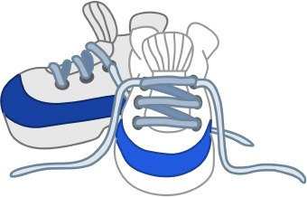

Exercise with Safety in Mind
As the days start getting shorter watch for people out and walking, running or riding bikes. Please consider wearing a safety vest, carrying a light and wearing light colored or high visibility clothing when exercising in the dark. Drivers, be alert and share the road.
Marvin Lee - Summer Concert Series
Only two shows left in September, Marvin Lee will continue bringing his country music concert series to Hale Park on Tuesday evening at 6:30pm, September 3 & 10 (weather permitting). This is a free event open to the public. Bring your lawn chairs and enjoy the late summer evening in Philo. The Philo Fire Department will be grilling pork chops for a fee.
Philo Country Music Shows
Two dates are set for the Philo Country Music show to be held at the R. E. Franks Center at 108 W. Madison St. in Philo on Sunday, November 3 and Sunday, December 8. The Branson-style music show begins at 3:00pm. Admission is taken at the door and concessions are available.

Philo Kids’ Festival
The Committee sends out a huge THANK YOU to all the sponsors, volunteers and everyone who participated or attended the Philo Kids’ Festival. While the weather had everyone on edge and pushed back the start time, the day turned out to be wonderful. The committee has already started planning for next year and would like feedback and ideas from the community. You can contact the village office or leave a comment on their Facebook page.
You can find more information on their Facebook page Philo Kids’ Festival. All proceeds are used to update the village parks and playground equipment.

Be a Good Neighbor
The Village Board encourages everyone to be a good neighbor and to keep the village clean and safe. Many of the calls we receive are just common courtesy, but from time to time an ordinance is required for guidelines. One of the most common questions is “Do I need a permit to put up a fence”? The answer to that is, “yes” and there is a $50 fee. We have posted the updated village Zoning and Subdivision ordinances on our web page along with building permit fees. You should be able to search these documents. Please call the office if you have any questions or need further information.
Other ways to be a good neighbor:
- Always pickup after your animals, particularly when they defecate on any property that does not belong to you. This includes, but not limited to public parks, the Franks Center property and Locust Grove Cemetery.
- By law, dogs must be on a leash when not on the owner’s property.
- Put trash receptacles away after garbage pickup.
- Keep our property neat and orderly. Do not leave piles of debris for extended periods of time. Also, help keep the village drainage system clear by not allowing debris to flow into drains.
- Be conscientious of noise levels such as early morning mowing or after dark.
- Be courteous when burning lawn debris. There are many people with breathing issues. Smoke from burning leaves is detrimental to their health. Do not burn wet piles of leaves, sticks and other plants. If you have any questions about the regulations and ordinances in the Village you may call the office for clarification.
- SLOW DOWN! Speed limits are posted. If you are unsure….go slow!

COMING SOON!
Countryside United Methodist Church -- Annual Harvest Breakfast every Wednesday morning in October from 6:00 - 8:00 am. Any and all donation collected will go to Unity East and West funds for students in need as well as Midwest Distribution Center

Unity Show Choir -- Fall Show Case will perform two shows on Saturday, October 19. Check out all the Unity Music event at https://unitymusicboosters.org Get out and support the Unity Fine Arts.

Village Board and Officials

Village President  Larry R. Franks ..... 684-2493.. LRFranks11@yahoo.com  Village Clerk  Judy Kirby ............... 684-2118  Village Treasurer  Kevin Chalmers………….(217) 441-2927  Trustees  Steve Sappenfield.. 621-3084.. Steve@philosports.com  Pat Pioletti............. 684-2172.. pw64@comcast.net  Paul Brady ……..... 684-2540.. paul-brady@comcast.net  Rachael Garrett…. 714-8484.. rachaelgarrett@comcast.net  Steve Messman … 493-8762.messmanfarms@comcast.net  Tom Kelley………….. 369-6690…tom.kelley@syngenta.com | Deputy Village Clerk & R. E. Franks Meeting Center Rentals  Janet Decker.. 684-2562.. janet@villageofphilo.com  127 W. Washington St., Monday - Friday 8am - 11am  Village Maintenance & Building Inspector  David Traxler .......................................... 684-2674 105 E. Washington St., Monday-Friday 7am - 4pm  Philo Planning Commission  Chris Payne, Co - Chair ............................... 684-2226  Karl Helmink, Co - Chair.......karl.helmink@comcast.net  ESDA Co-Coordinators  Richard Brand ...................................... 778-8259  Chris Lueth……………………………………………..377-9627

View meeting agendas & minutes on the Web at www.villageofphilo.com

PRSRT STD
ECRWSS
U.S. POSTAGE
PAID
EDDM Retail

Village of Philo
127 W. Washington St.
P.O. Box 72
Philo, IL 61864-0072

*****************ECRWSS****
Local
Postal Customer

