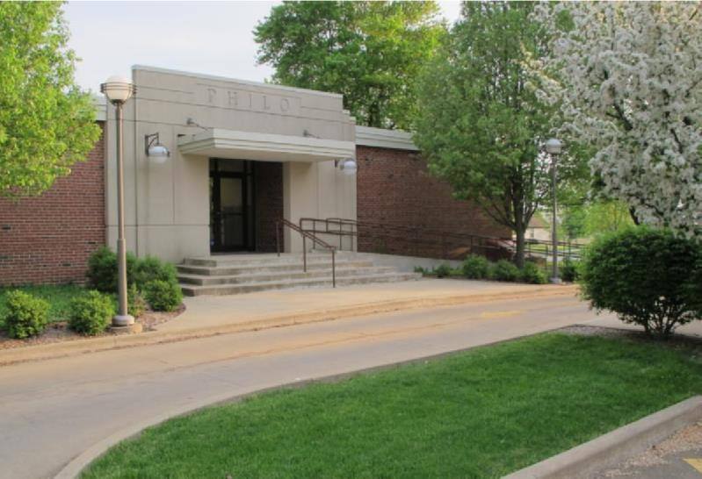

News from the Best

Little Town in
Illinois

Summer 2018
June - August

Village of Philo

FROM THE Mayor’s Desk
By: Larry Franks

We had a wet start to spring. I bet all the farmers and gardeners out there are glad it finally dried up and warmed up. It gave us a chance at the Village to see how our drainage project stands up. We found a few areas that need to be reworked and have been in contact with the contractor. The hill will get re-seeded. Please stay off the hill this summer so we can get the grass established and especially No Motorized Vehicles.

The Planning Commission and Zoning Board have been combined into one advisory unit. They have been hard at work with MSA Associates to re-vamp our Zoning Ordinance and are working on the Subdivision Ordinance. It is my hope, along with the village Trustees that we can get these two ordinances, along with all our other ordinances codified so they can be put on our new web page and easily searched by the public. It is a very big task that will take some time. If you ever have any questions about ordinances in the village you can call Janet at the village office or send her an e-mail.

Another thing I am really excited about this summer is the Philo Fun Day coming back. I am happy that a committee has stepped up to raise some money and help update our parks. The Fun Day will be one of the steps in getting new playground equipment for the parks. On behalf of myself and the Village Board, we thank the committee and look forward to their progress.

Have a safe and enjoyable summer!!

IN OTHER VILLAGE HAPPENINGS
From the meeting minutes:
February - A representative from Good Energy made a proposal to the Trustees to contract to purchase electric supply at a discount. The bid date was to be March 7 and Mayor Franks and Trustee Pioletti to attended bid process.
Request from Darrell & Regina Rice for subdivision waiver to build a home ½ mile from their current property which would be within the 1 ½ mile jurisdiction for the Village.
The Board voted not to participate in the electronics collection events held by the Champaign County Regional Planning Commission since we provide our own Clean-up Day and recycling events to Philo residents.
The Philo Gas & Car Wash has started negotiations for sale to a new owner.
March - Tarah Block presented to the Board a proposal for a gaming parlor in the upper floor of the 101 E. Washington building to help supplement her Children’s Boutique that she would like to move to the building.
Village resident commented that the drainage project is working well and he hasn’t had water in his basement and it drained quickly from his yard.
Overview of progress being made on the Zoning ordinance was presented.
The new scoreboard was installed and working properly. Also, reported by Village Maintenance was the burn pile from brush pick-up days was getting full and need to haul off the excess. In Old Business, the rental contract with Hugs & Bugs was finalized. The electrical aggregation contract was also signed and contracted for 36 months.
All minutes are posted on the web site the month they are approved. Visit www.villageofphilo.com for full transcript.

Recycling Rules
Philo residents are fortunate to have a recycling service located right in town (under the water tower). Unfortunately, from time to time, regular garbage is put in the recycling dumpsters which means all contents of the dumpster must be disposed of as garbage. Recycling or unacceptable materials left outside of dumpsters is not picked up by the recycling vendor and creates extra cost to the Village. Please be considerate and come back another time if the containers are full. Thank you for being concerned with the environment and appearance of our Village!
From Dave Traxler,
Village Maintenance

Brush pick-up is scheduled the 1st & 15th of each month. If either of those dates falls on a weekend or holiday, pick-up will be the next business day immediately following.

DO NOT PILE BRUSH IN ROAD OR ALLEYWAYS. KEEP IT ON YOUR PROPERTY.
If you have questions, please contact Dave Traxler at 684-2674.

Philo Public Library Home Delivery
Home delivery service is available to anyone who is physically unable to visit the Philo Public Library. If you have a Philo Library card and have a temporary or long-term illness, injury, disability, limited mobility or are a senior citizen without transportation, you may be eligible for this service. Contact the Library at 684-2896 and ask to register for Home Deliver Services to get started.
Other library news: Monday’s in June from 1:30 - 2:30pm will be the Summer Reading Program for elementary age kids that have completed kindergarten.
Starting Wednesday June 6 at 10:00am Miss Jill’s Pre-School Summer Programs will be held in June. Middle and High School Reading Programs are not structured like the younger programs, however the library is offering incentives to continue reading in the summer months. On Thursday’s in June, Crafts ‘n Stuff will be held for kindergarten and beyond. Space is limited, please register for the Craft classes. Stop by the library for full information on all their programs and a nice cool place to enjoy a hot afternoon.
Philo Veterans Monument
The Philo Veterans Monument committee accepts applications for nominations year-round. If you are a veteran or know a veteran who meets the criteria and would like to be inscribed on the monument, you can pick up an application at the Philo Township Library or in the Village Office at the R. E. Franks Meeting Center.

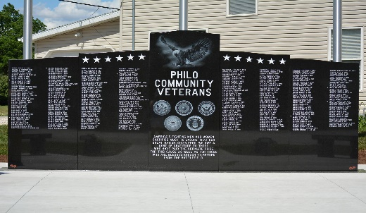

Post Offices Collect Food for Charity
On May 12, 2018 the local postal carriers collected non-perishable food items for local charities. The Catholic Charities pantry at St. Patrick’s parish and the Giving Place both in Tolono received 2,625 pounds of food from generous postal patrons.
Catholic Charities pantry at St. Patrick’s Parish is open for distribution of food to Unit 7 families in need on Monday’s from 5:00 - 6:30pm and Friday’s from 9:00 - 10:30am. The Giving Place is open for food distribution on Wednesday evenings from 4:00 - 6:00pm and also for clothing distribution on the 1st Saturday of the month.

R.E. Franks Meeting Center
Are you looking for a facility for your family gatherings, holiday parties or just someplace to let the kids run off some steam? Do you coach a travel basketball or volleyball team and need a practice facility?
The meeting center is well-suited for weddings, receptions, family reunions, birthday parties, bridal and baby showers, anniversary celebrations and stage performances. Amenities include a kitchenette, stage, large projection screen and integrated sound system for everything from live bands to your MP3 player.
The space can equally accommodate informal or formal athletic events. Basketball and volleyball courts are available. For games there are bleachers, two locker rooms, scoreboard and announcing equipment. The Board room is also available for small gatherings. Philo residents receive a 10% discount off their rental.
For more information and to schedule a visit or for reservations, contact Janet Decker, Rental Coordinator at 684-2562 or janet@villageofphilo.com. Further details and information are available online at www.villageofphilo.com.

11th Annual Run4Raley
The 11th annual Run4Raley will take place Friday, August 10 @ 7:00pm. The event will begin on Washington Street again this year. Beginning at 4:00pm, Washington Street between Jackson and Harrison Streets will be closed off to set up for the start of the run and will open back up by 9:00pm.
You can now register for the 11th Annual Run4Raley at www.umdf.org/Run4Raley.
Be sure to keep looking out for our emails & following us on Facebook/Instagram/Twitter for more information on other things surrounding the event! We would love it if you would recruit some friends to come with you!

Philo Kid’s Festival
Mark your calendar for Saturday, August 18!
A new committee has been formed to help raise money for our park playgrounds and new equipment. The committee is excited to announce that there will be a Philo Festival especially geared toward the kids on Saturday, August 18 at Hale Park.
The day will start off with a parade featuring golf carts. Also planned is a car show, bounce houses, vendors, a bags tournament and finishing off in the evening with a dj and dance.
Watch the County Star and flyers for complete details.

Marvin Lee - Summer Concert Series
Once again Marvin Lee will be bringing his country music concert series to Hale Park every Tuesday evening in August and the first two Tuesday’s in September. This is a free event open to the public. Bring your lawn chairs and enjoy the late summer evening in Philo. The Philo Fire Department will have pork chops on hand for a fee.

New Web Site
Our new web site is up and running. Take a look and call the office or send Janet an e-mail with feedback. You can read this Newsletter on-line (in color). Meeting agendas are posted on Monday before the monthly board meeting and the complete minutes are posted after approval. The Planning Commission is working to update ordinances and those will be posted on the web page eventually for easy search.

SUMMER REMINDERS

Pool Fence Ordinance
The Village of Philo has an ordinance requiring anyone with an above ground swimming pool to have a fence that extends at least 2’ above the exterior of the pool and have a locking gate. For in ground pools the fence must be at least 4’ in height from the ground.

Annual Golf Cart Registration
As the warm weather returns so does the use of golf carts by some residents to get around the village. Per a 2009 ordinance, individuals who intend to drive their golf carts on Village streets must obtain a permit from the Village and have their carts inspected, among other criteria.
-Qualifying golf carts must have a maximum attainable speed of 20 miles per hour and be properly equipped.
-Any person who operates a golf cart must be at least 18 years of age and possess a valid driver’s license and insurance coverage. The maximum occupancy in the cart is one person per bucket seat or two people per bench seat.
-Golf carts are to be driven on streets only and from sunrise to sunset.
-The annual permit fee is $15 for senior citizens ages 65 years and older and $30 for all others.
-Golf cart inspection appointments may be made with Trustee Paul Brady at paul-brady@comcast.net or by phone at 684-2540.
ATV’s and other off-road vehicles are NOT allowed on village streets or properties.
Violations are punishable by a fine of not less than $100 or more than $500 for each violation.
The ordinance and complete list of requirements is available at the Philo Village Office inside the R. E. Franks Meeting Center at 127 West Washington Street. Office hours are Monday through Friday from 8:00 a.m. to 11:00 a.m. You may call 684-2562 or e-mail inquiries to janet@villageofphilo.com.

Burning Regulations
Residents may burn leaves, sticks and other plants grown or generated in the Village of Philo in a safe manner during daylight hours. Please be conscious of how it impacts your neighbors. Many people have allergies or sensitivities to smoke. Do not burn wet leaves.

Village Board and Officials
Mayor  Larry R. Franks ..... 684-2493.. LRFranks11@yahoo.com  Village Clerk  Judy Kirby ............... 684-2118  Village Treasurer  Rod Schweighart .... 840-6029  Trustees  John Mumma ….. 684-2625.. JMumma4740@aol.com  Steve Sappenfield.. 621-3084.. Steve@philosports.com  Pat Pioletti............. 684-2172.. pw64@comcast.net  Paul Brady ……..... 684-2540.. paul-brady@comcast.net  Rachael Garrett…. 714-8484.. rachaelgarrett@comcast.net  Steve Messman … 493-8762.messmanfarms@comcast.net | Deputy Village Clerk & R. E. Franks Meeting Center Rental Coordinator  Janet Decker.. 684-2562.. janet@villageofphilo.com  127 W. Washington St., Monday - Friday 8am - 11am  Village Maintenance & Building Inspector  David Traxler .......................................... 684-2674 105 E. Washington St., Monday-Friday 7am - 4 pm  Philo Planning Commission  Chris Payne, Co-Chair ............................... 684-2226  Karl Helmink, Co-Chair.......karl.helmink@comcast.net  ESDA Co-Coordinators  Richard Brand ...................................... 778-8259  Chris Lueth……………………………………………..377-9627

View meeting agendas & minutes on the Web at www.villageofphilo.com

PRSRT STD
ECRWSS
U.S. POSTAGE
PAID
EDDM Retail

Village of Philo
127 W. Washington St.
P.O. Box 72
Philo, IL 61864-0072

*****************ECRWSS****
Local
Postal Customer

